Professional Development Needs Assessment
Spring 2023- Faculty
Fine Arts, Communication, and Humanities
n=47

What is your ethnicity? What is your area?
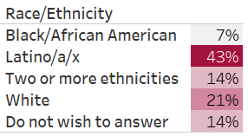
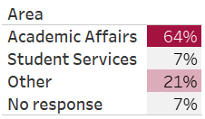

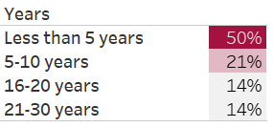
What is your gender? How long have you worked at Compton College?
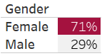

What kept you from participating in professional development activities?
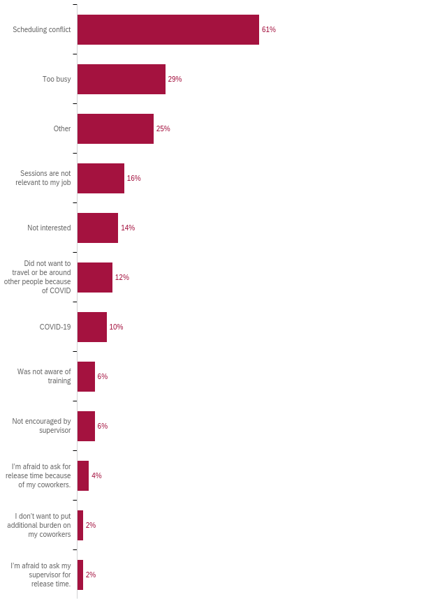

How many professional development hours did you attend in the last year?
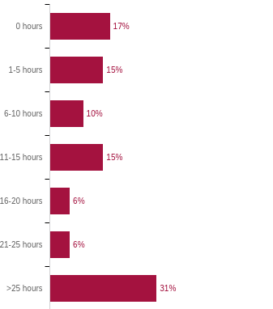

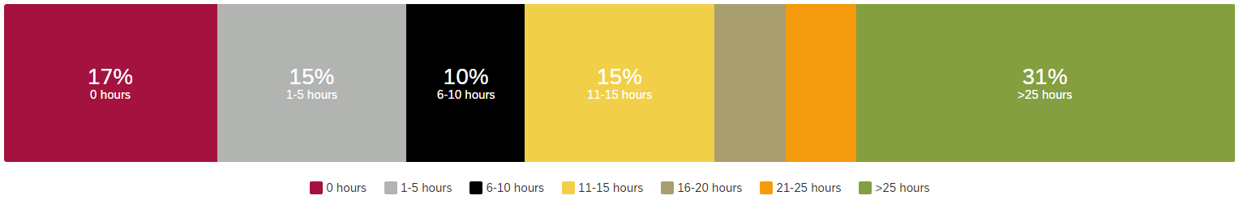

Professional Development for Guided Pathways
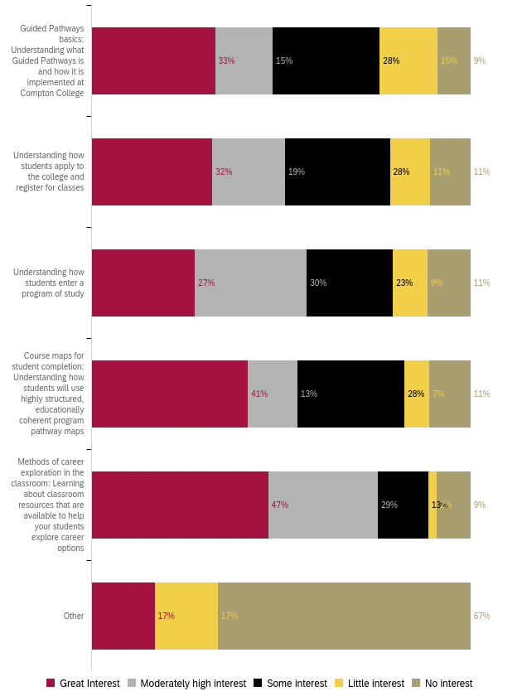
Professional Development to Enhance Teaching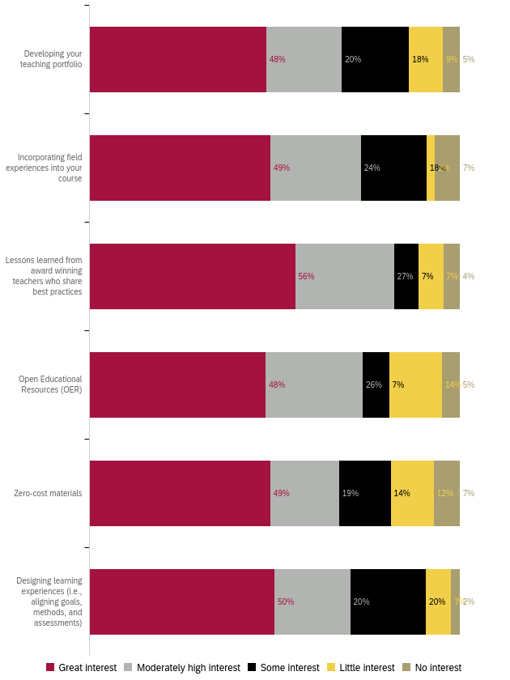
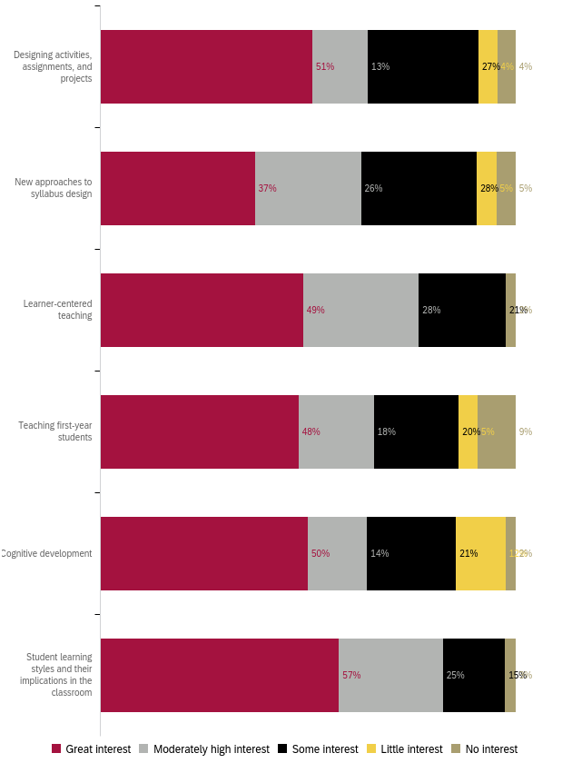
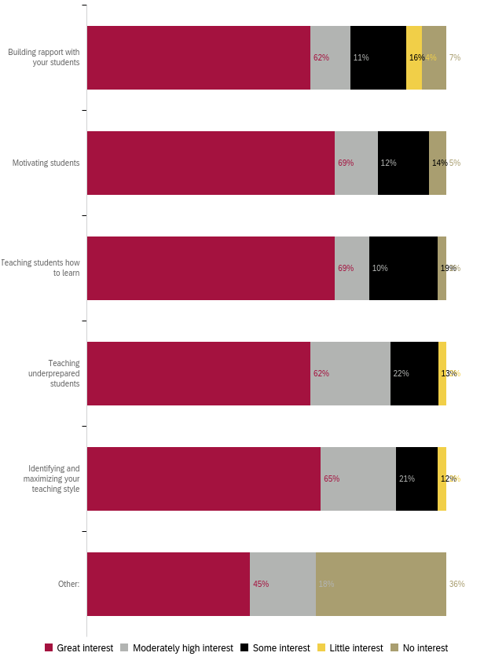
Professional Development for Curriculum Development 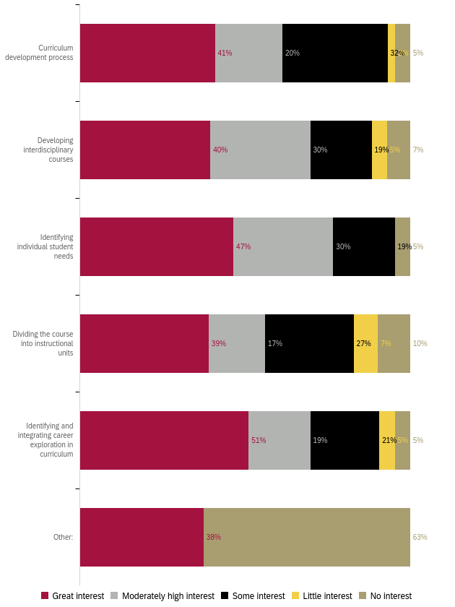
Professional Development for Diversity, Equity, and Inclusion in the Classroom
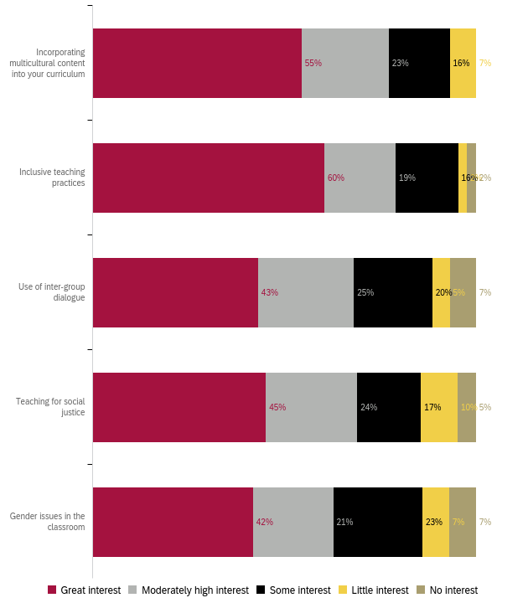
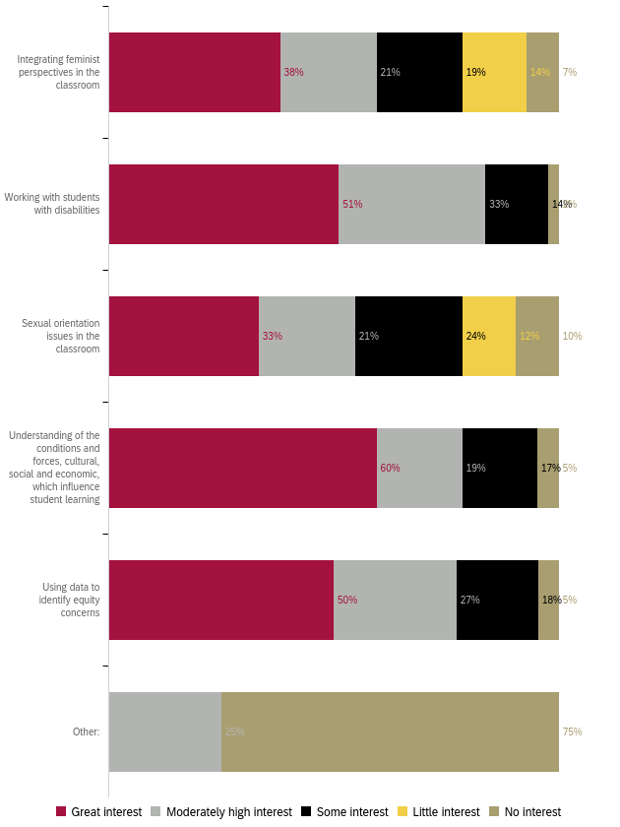
Professional Development to Improve Assessment
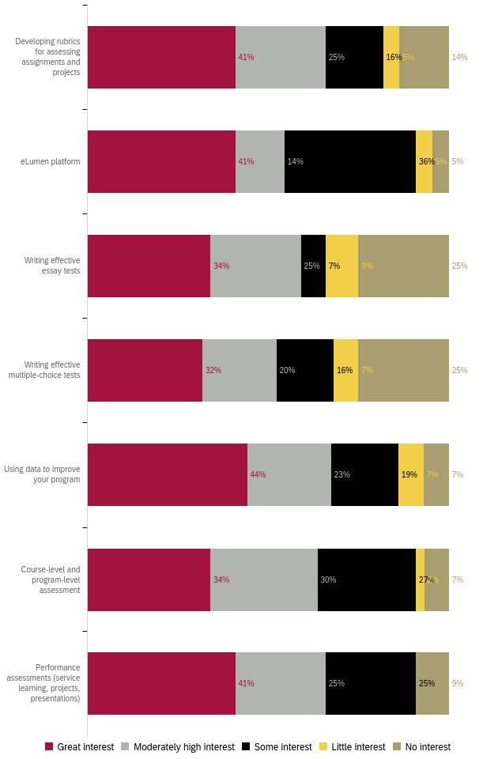

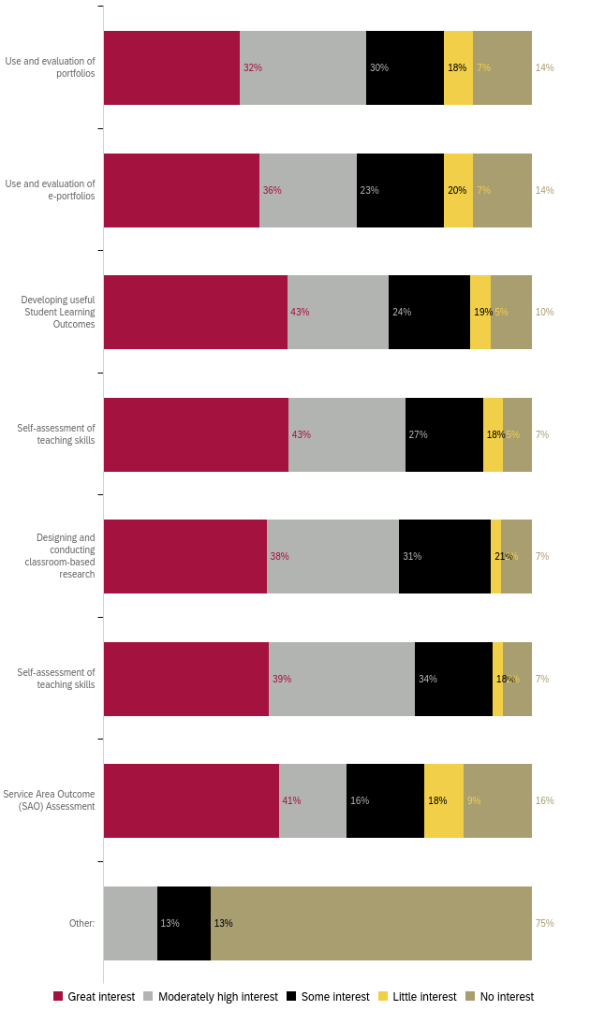

Professional Development for Use of Technology
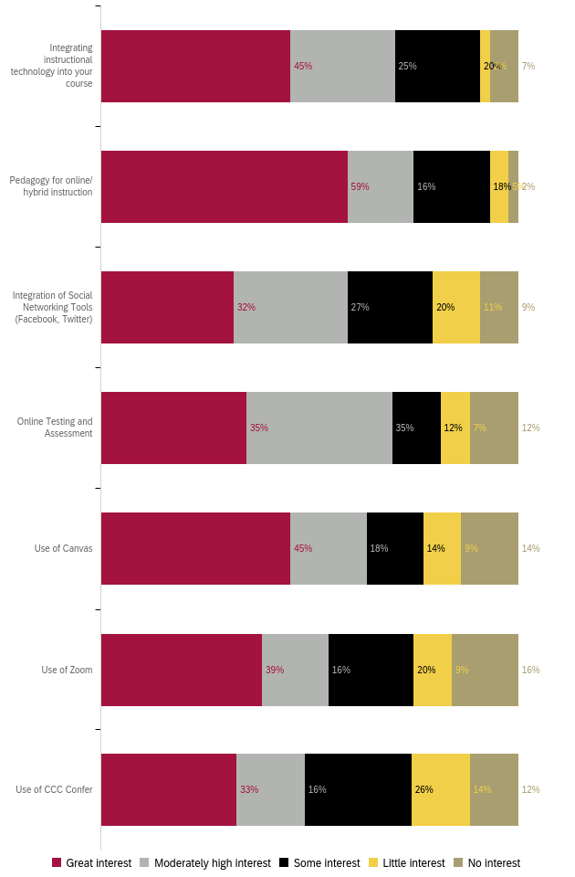
Professional Development for General Use of Technology
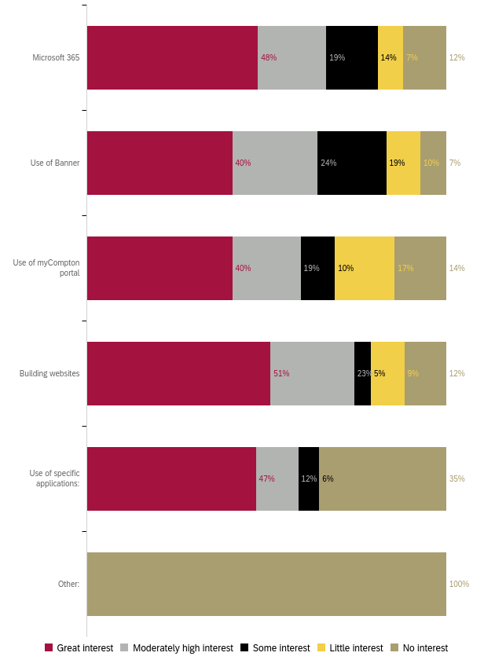

Professional Development for Classroom Management
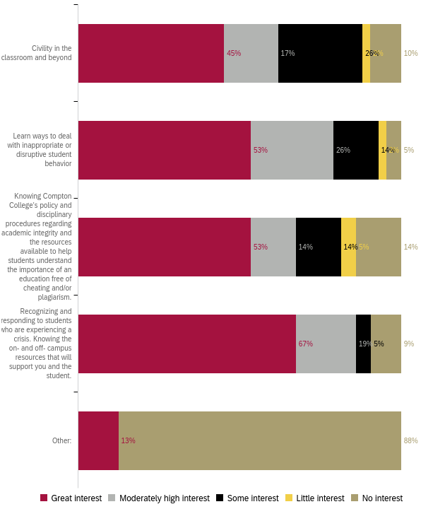
Professional Development for Compton College Policies and Procedures
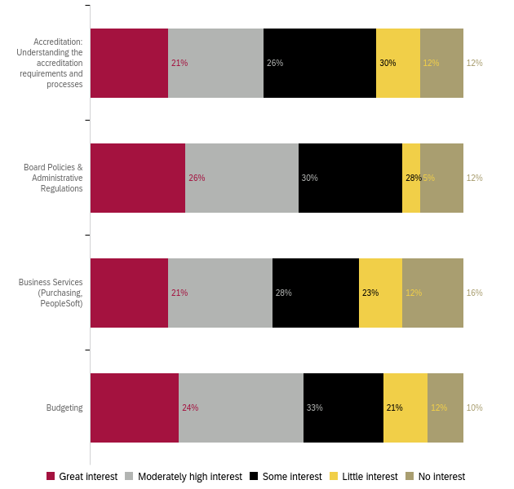
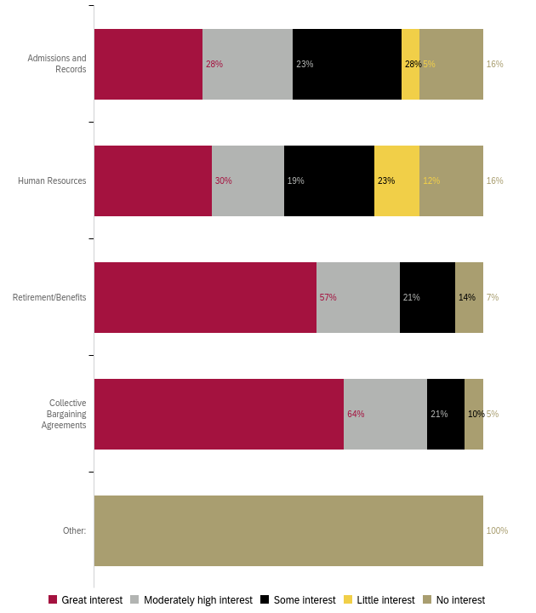
Professional Development for Health and Wellness 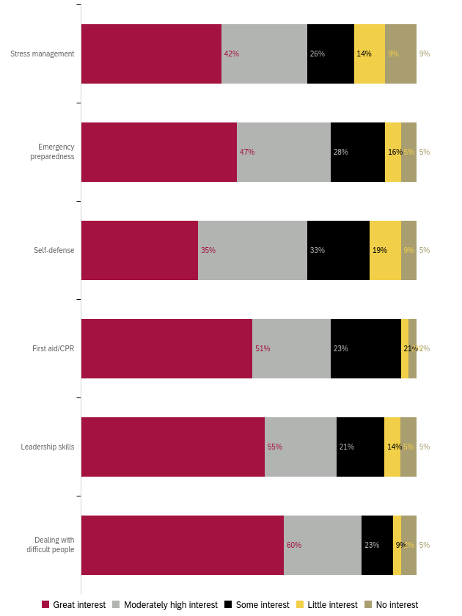
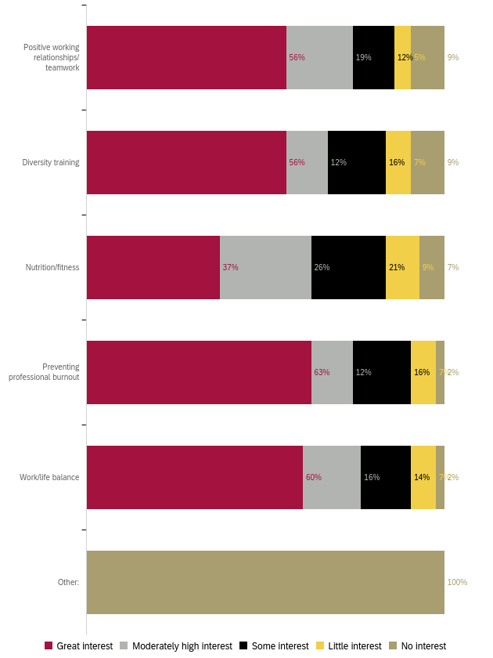
Professional Development to Enhance your Work
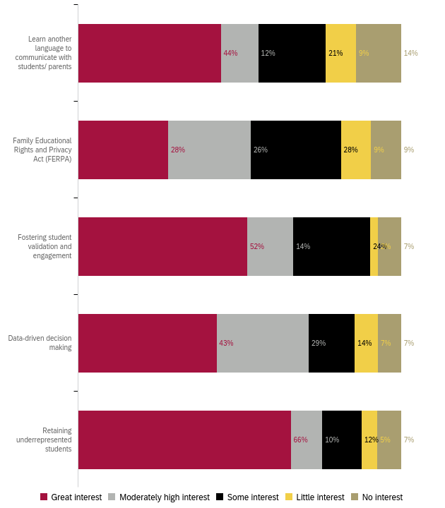

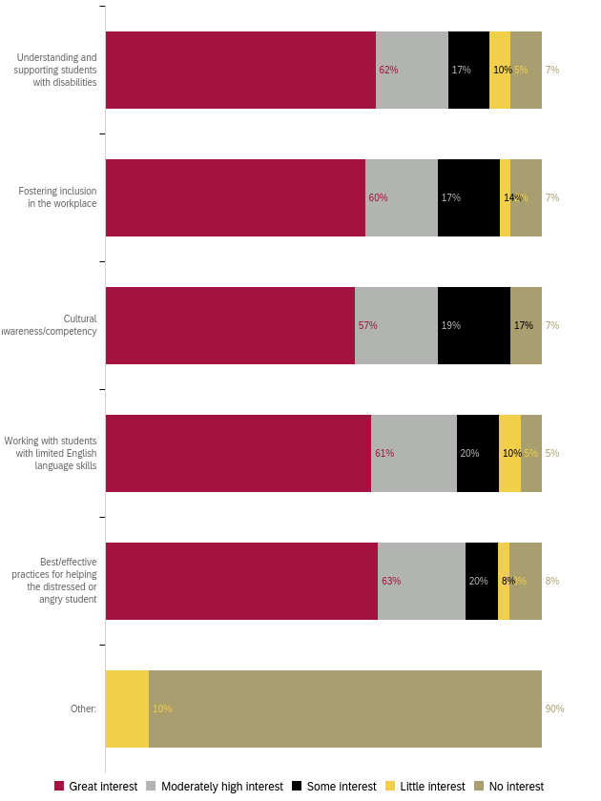
Professional Development for Leadership Skills
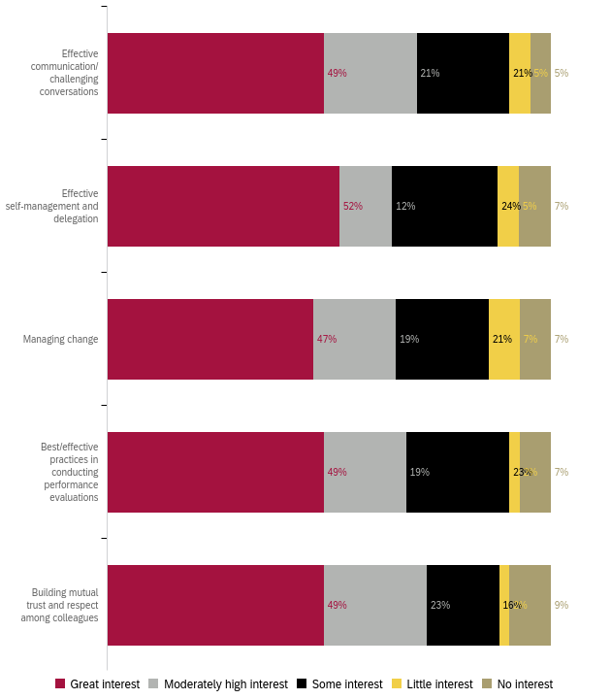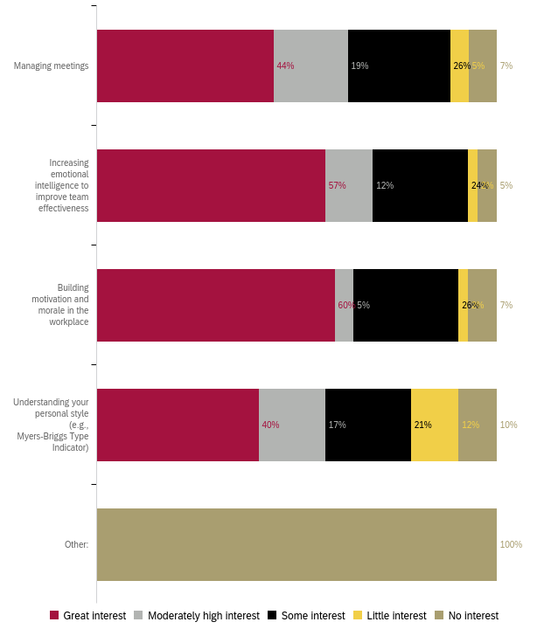

Preferred Professional Development Format 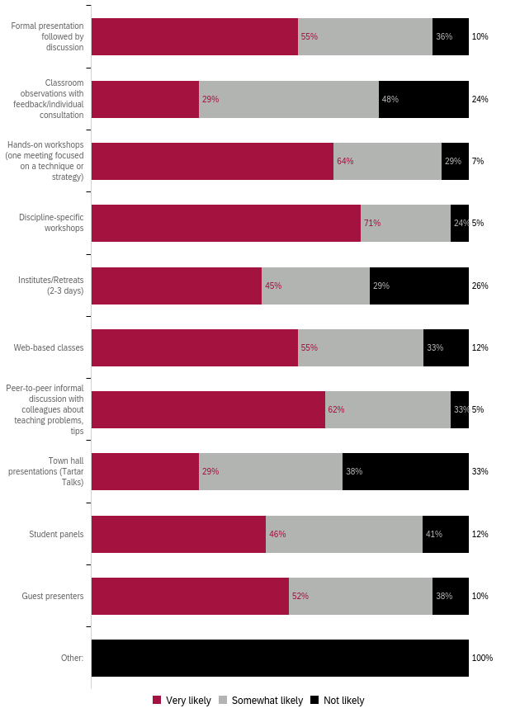

Preferred Format: Ranked 1 (first) to 5 (last)
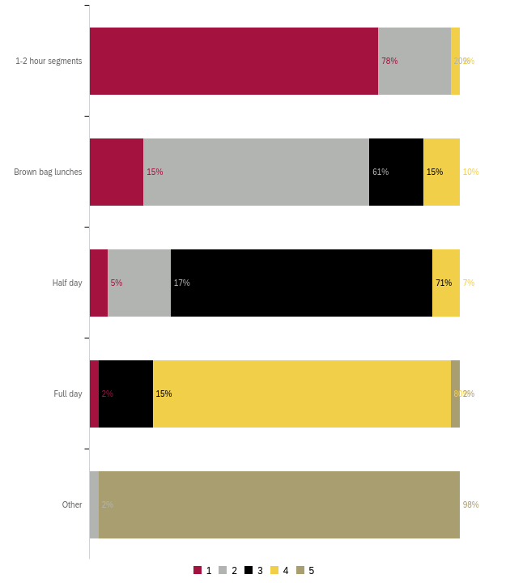
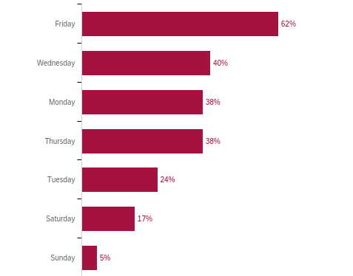
Preferred Day for Training

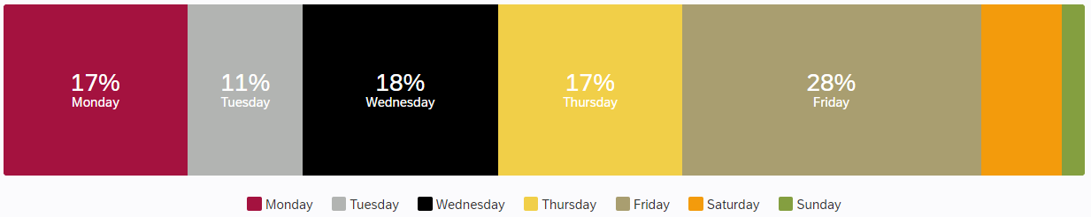

What do you need to enhance your career?
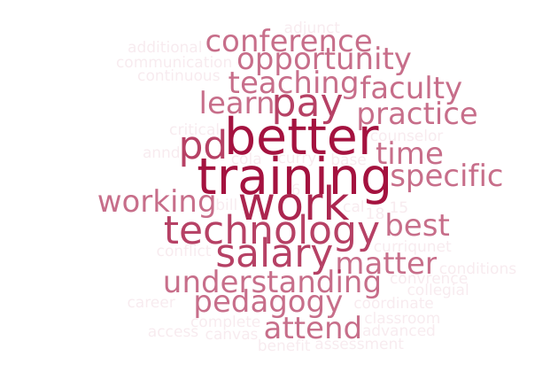
Responses:
- Nothing now (4)
- To learn the specific needs of this institution in order to help fill the gap and solve the needs of this institution.
- Better understanding of how tenure works at Compton - how to best present myself for tenure.
- attend more conference and maybe PD office can host office hours to help us complete the PPW
- Salary Increase, Benefits, Tuition Reimbursement, Leadership Development, Conference Presentations
- PD opportunities related to my subject matter
- More time to be able to do a better quality job. More pay so I don't have to teach as much, so I can dedicated the needed time to quality instead of quantity, trying to pay bills. Not getting COLA for the last 6 years means all faculty took a 15-18% pay cut from our Real Salaries. We DESPERATELY need a raise to make up for the horrendous inflation. We all have bills to pay, not just Dr. Curry, whose salary has more than kept up with inflation. He cannot keep saying there isn't money, where there is ALWAYS money for him. That is hypocritical to say the least and an insult to everyone working at the College. It tells all workers that Dr. Curry work is the only one that is valuable. Then he should do all the jobs at the College by himself if he things his work is the only one that matters.
- Better work conditions, environment, and collegiality.
- As an adjunct faculty, I would like access to a leader (dean, full time faculty, HR, coordinator, etc.) who actually has time to invest in the PD of part time faculty.
- Trainings in technology, communication, conflict resolution, supporting marginalized students
- Continuous learning on best practices as a counselor at Compton College. Regular updates on information, updates on procedures, policies, and services at Compton College.
- Discipline-specific offerings are my favorite--almost always very useful.
- More Canvas aNnd other online training
- advanced critical assessment- Evidence based practice..
- More teaching opportunities and higher paying positions would enhance my career.
- More guidance
- Better salary. Compton college is a very underpaid college in cal.
- Training on High School pedagogy and classroom management.
- More Trainings.
- Be able to attend convrences.
- Effective internet technology
- Learn additional skills using technology.
- More training on Dual Enrollment pedagogy and working with HS partners. Understanding Course Review, Department Review, and other profressional work on Curriqunet
- Better pay.
- Recognition of work ethic and my dedication to teaching.
What support or learning opportunity would help you do your job better?
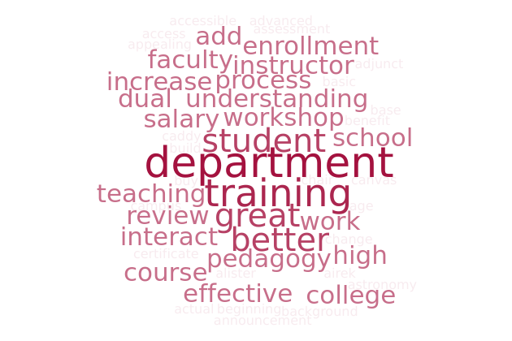
Responses:
- N/A (4)
- More nursing focused training and teaching
- Having someone readily available through email communication so that whenever I have a question I can email them and get a prompt response.
- "support on dual enrollment - how to teach high schoolers vs. college age students the same content. how to manage a high school class.
- how to build my tenure review portfolio."
- Retirement planning, buying properties for our personal economic wellbeing
- Salary Increase, Benefits, Tuition Reimbursement, Leadership Development, Conference Presentations
- Collaborating with the other instructors within my department/subject matter.
- Being new to online teaching (only beginning with the pandemic), I need help on how to better my online courses. I now have basic courses but I could do so much more to humanize them, add more interactive material, and otherwise enhance my courses so they are more appealing and more effective for my students. I also want to diversify my curriculum and include more culturally relevant information to ensure the information is appealing and relevant to my students.
- "Self-paced short courses in Canvas that allow to earn certificates. Please work on accessibility for faculty training. Many power points presented in trainings are not legible, are crowded, or are very hard to follow with fonts and background people choose. "
- Hands on workshops
- Up to date announcements and procedures for each department and service on campus. As a newer employee to Compton College, I am becoming more familiar with all the services, how students access them and changing procedures for each department and how they provide services to students. Finding a way to keep the campus employees up to date would be great to effective serve students with out adding confusion or difficulty to the process (e.g. encouraging websites for each department are up to date and user friendly).
- See above.
- advanced critical assessment- Evidence based practice..
- A clear understanding of course expectations and resources, and an actual division chair would great help do my job better.
- Cross-training from departments that counseling interacts with to better understand their processes.
- Increase rate salary to faculty.
- PD on High School Pedagogy and Classroom Management
- More Workshops .
- Monthly department meetings: physics and astronomy.
- A very motivating remuneration would help adjunct instructors significantly.
- We have great help with Airek Matthews and Alister Caddy.
- More training on Dual Enrollment pedagogy and working with HS partners. Understanding Course Review, Department Review, and other profressional work on Curriqunet
- stipends to complete higher degree, MA or PhD
- I'm not sure.
Is there anything else we should know to help build a robust, useful professional development offering?
Responses:
- Nothing now (12)
- Love the newsletters and emails that are sent. LOVE the compassion fatigue. I prefer the Yoga sessions in the mornings.
- I would love to work one on one with an instructional designer to get pointers for how to improve my Canvas shells.
- Please include a menu of choices for professional development day. This can help to meet our needs. Having 1-2 hour segments to focus on OER workshops, SLOs, AI, developing curriculum, etc. It is frustrating to have to seat half day listening to one or two persons talk. We should have the opportunity to choose activities from variety of offerings in PD day.
- advanced critical assessment- Evidence based practice..
- Encourage leadership to make professional development accessible to part-timers during their paid time.
- The union has to do something about faculty underpaid salaries.
- Everything is fine. Thank you!
- More computer apps to enhance in our teaching.
- Pedagogy trainings done by other Community College faculty.
- Appendix A: “Other” Responses
Ethnicity “Other” responses:
- Hispano

Non-participation “Other” responses:
- I was participating in various PD activities (4)
- Do PD outside Compton
- I wasn't employed at Compton College yet (3)
- Was informed that I cannot participate in professional development during my work hours because it is not considered direct student contact.
- I did not know i could request a sub to attend PD events.

PD for GPD “Other” responses:
- Equitable Teaching Practices, Leading from the Middle, Campus Collaborative PD
PD to Enhance Teaching “Other” responses:
- Developing a relationship rich classroom
- Teaching Dual Enrollment High School Student: Prada gift and classroom management
- None
- Dual Enrollment Teaching Methods
- Ethics

PD for Curriculum Development “Other” responses:
- Teaching with poverty in mind

PD For DEI “Other” responses:
- Working with Formerly Incarcerated Students

PD for Tech “Specific Applications” responses:
- CRM ADVISE
- Word
- Use of Canva
- R, RStudio, Python, Excel

PD for Tech “Classroom Management” responses:
- How to be a successful college instructor at the high schools I.E. pedagoy, classroom management, small classroom sizes, ettc. (Dual Enrollment)
- Classroom Manegement for Dual Enrollment

PD Format (types of trainings) “Other” responses:
- 3 hours

“Other” responses listed in Appendix A
“Other” responses listed in Appendix A
“Other” responses listed in Appendix A
“Other” responses listed in Appendix A
“Other” responses listed in Appendix A
“Other” responses listed in Appendix A
“Specific Applications” and “Other responses listed in Appendix A
“Other” responses listed in Appendix A
“Other” responses listed in Appendix A

