Professional Development Needs Assessment
Spring 2023- Faculty
Health and Public Services
n=8

What is your ethnicity? What is your area?
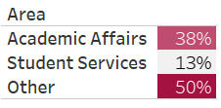
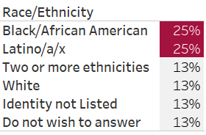

What is your gender? How long have you worked at Compton College?
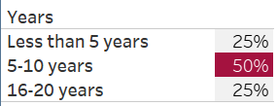
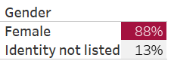

What kept you from participating in professional development activities?
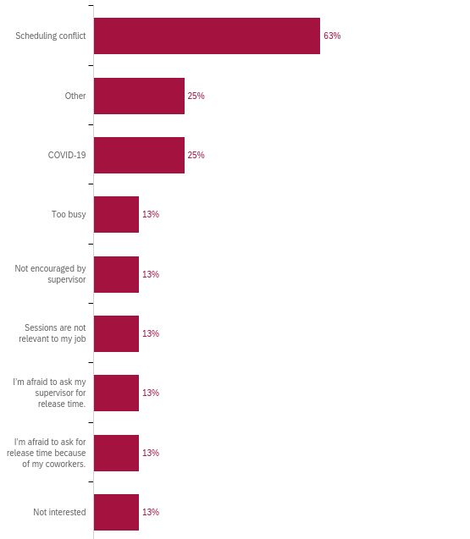

How many professional development hours did you attend in the last year?
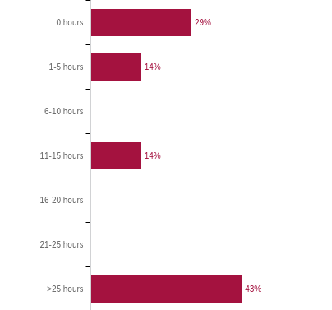

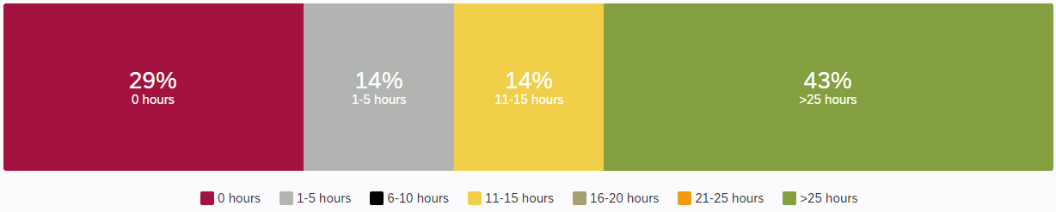

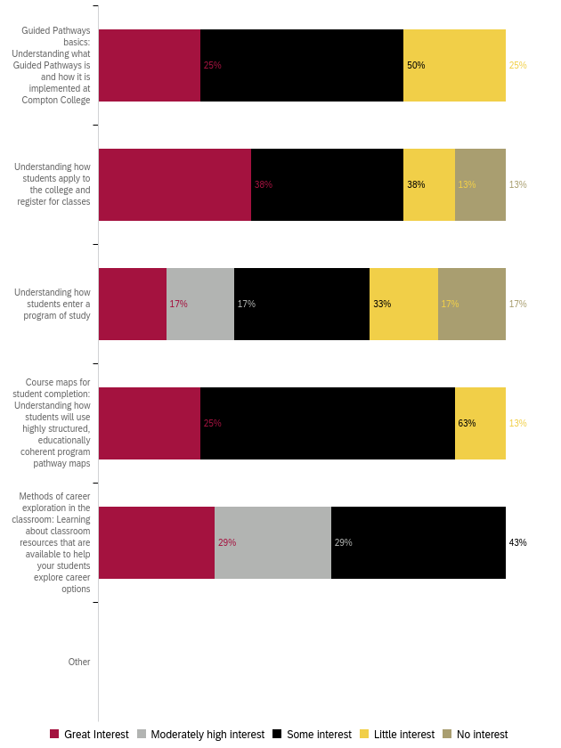
Professional Development for Guided Pathways

Professional Development to Enhance Teaching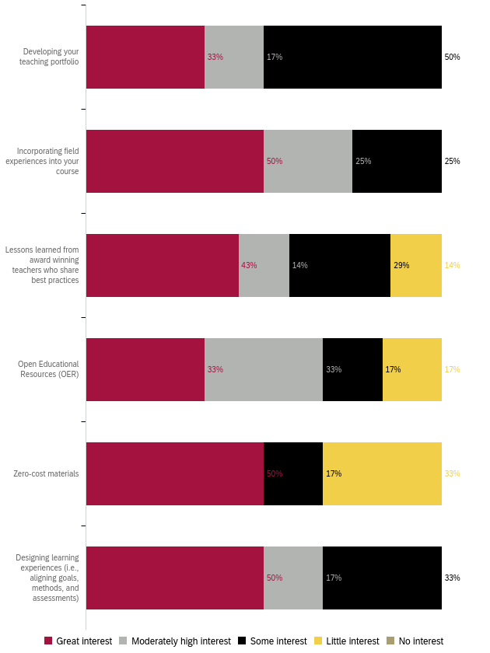
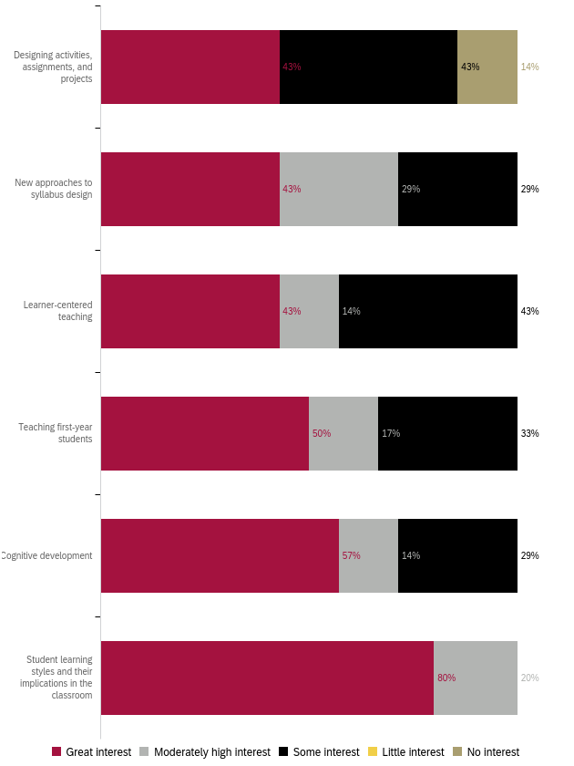
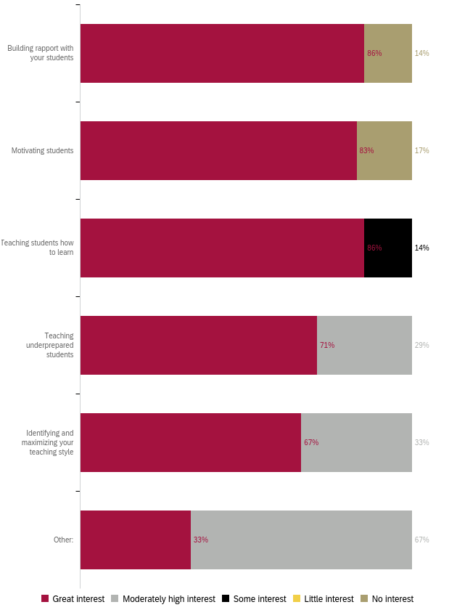
Professional Development for Curriculum Development 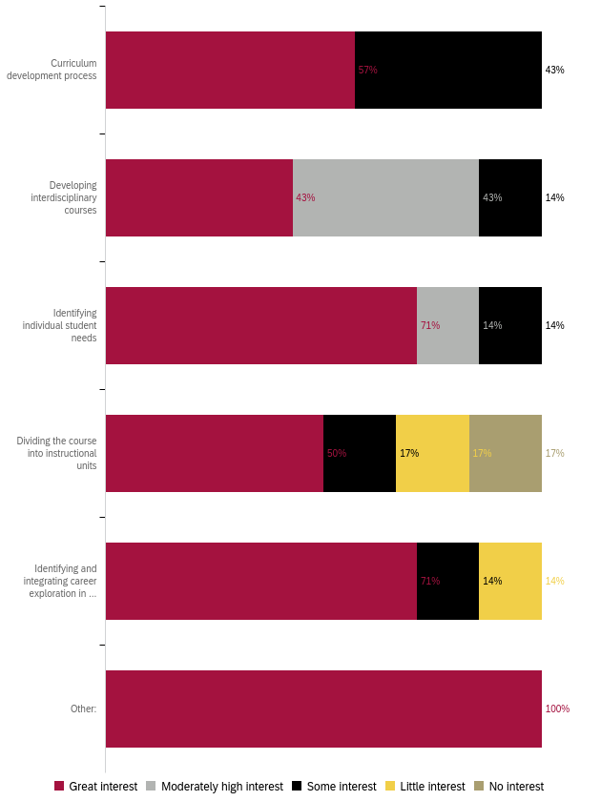
Professional Development for Diversity, Equity, and Inclusion in the Classroom
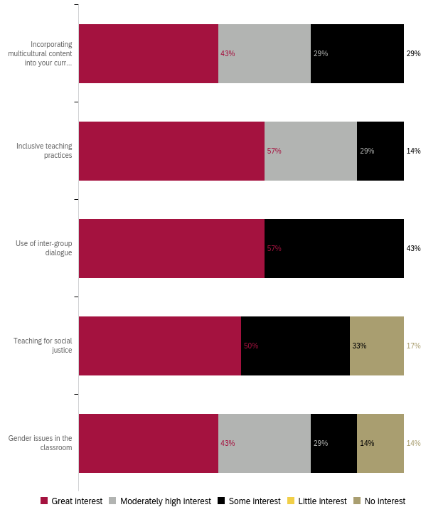

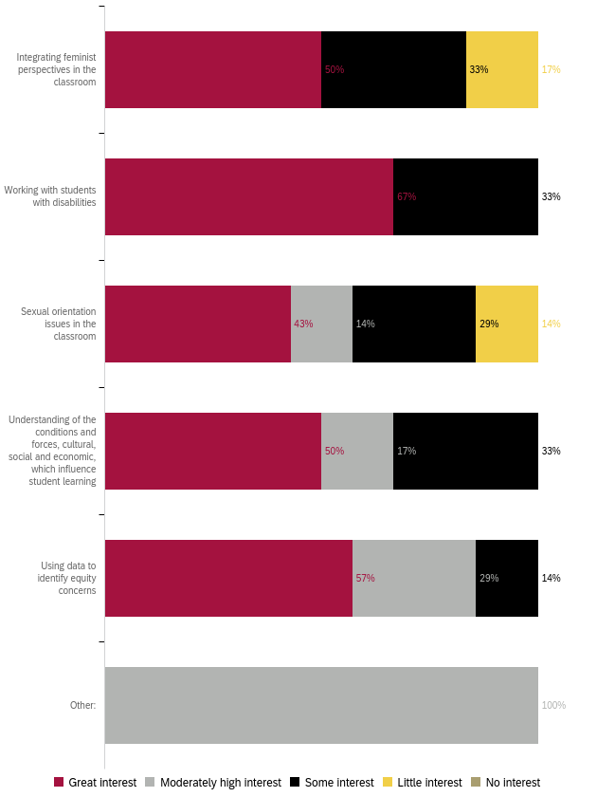
Professional Development to Improve Assessment
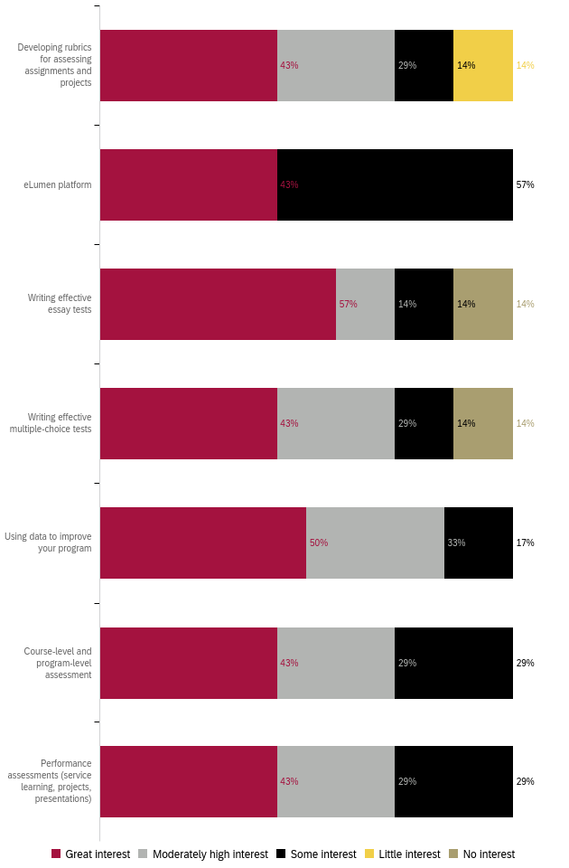

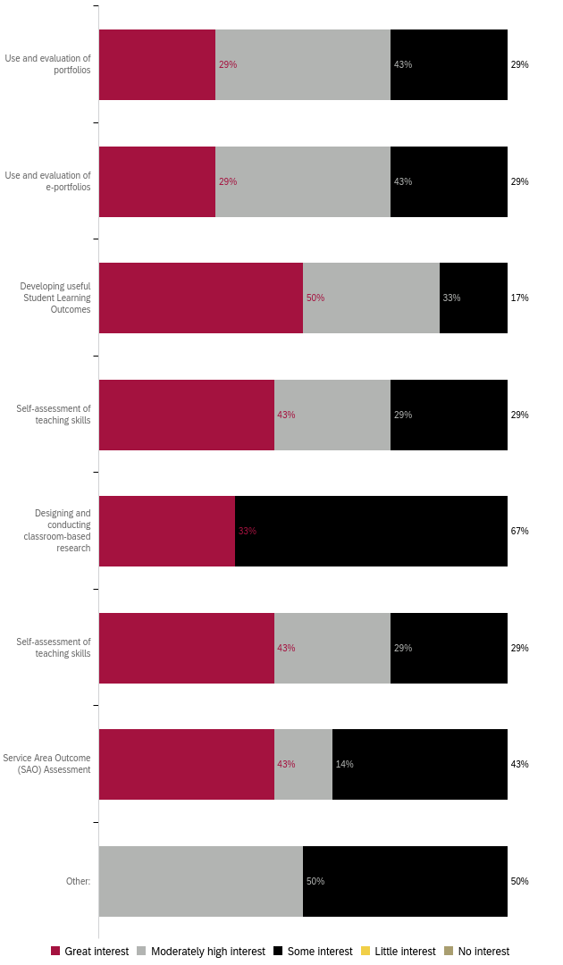

Professional Development for Use of Technology
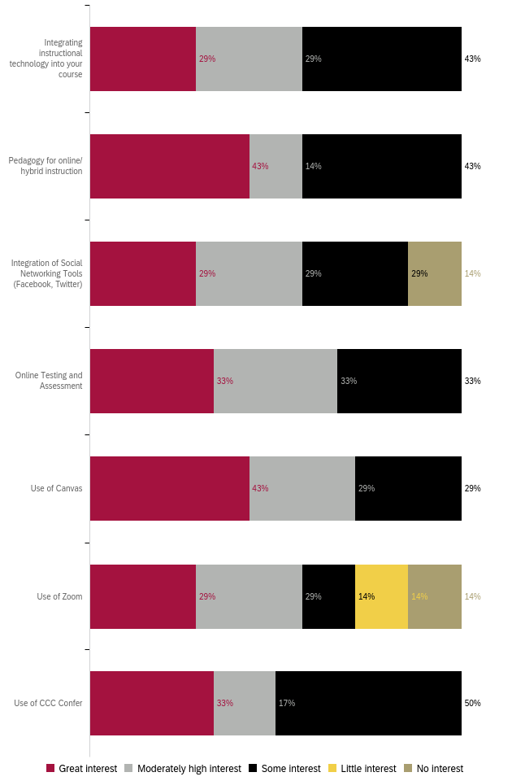
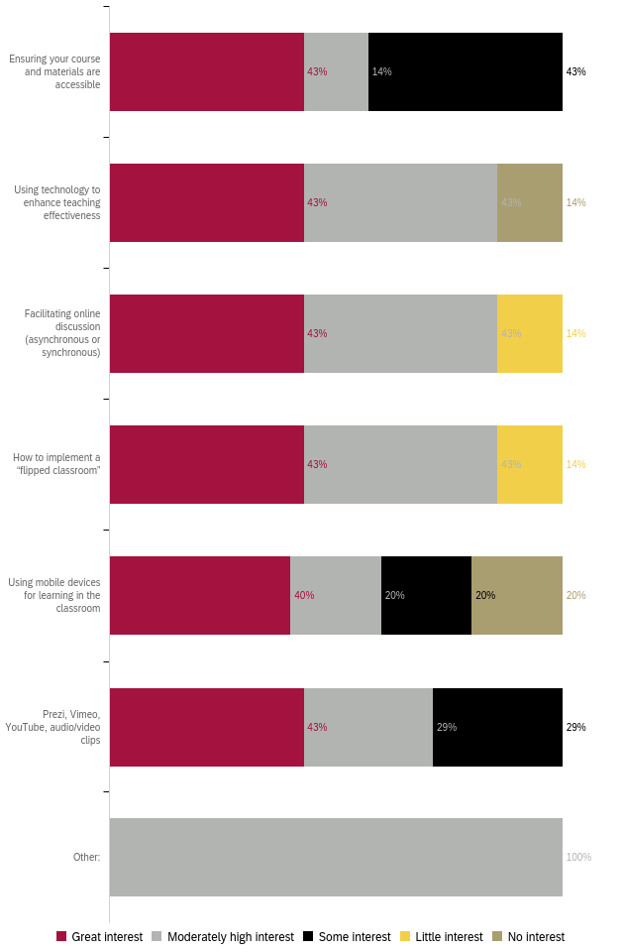
Professional Development for General Use of Technology
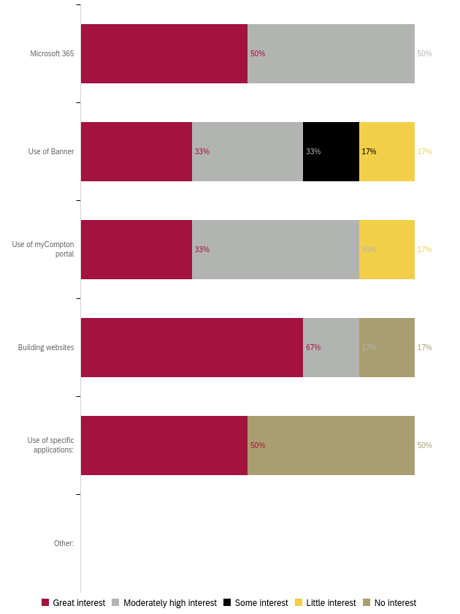

Professional Development for Classroom Management
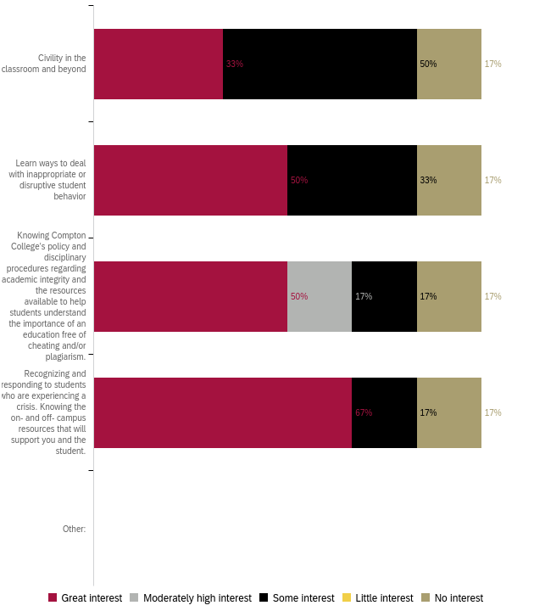
Professional Development for Compton College Policies and Procedures
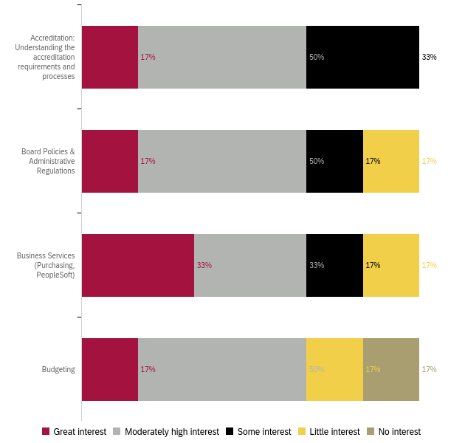
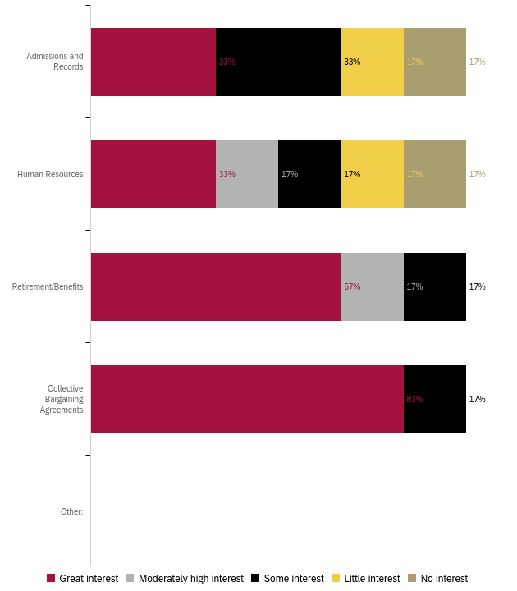
Professional Development for Health and Wellness 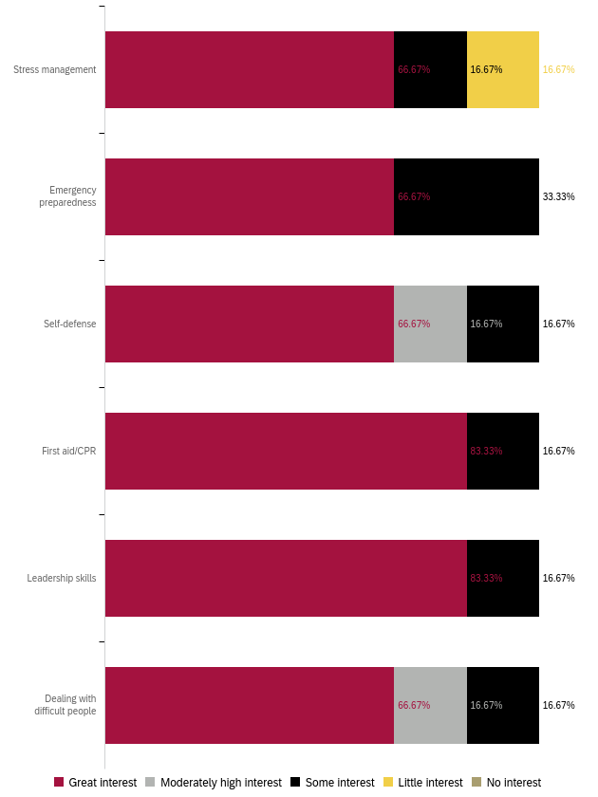

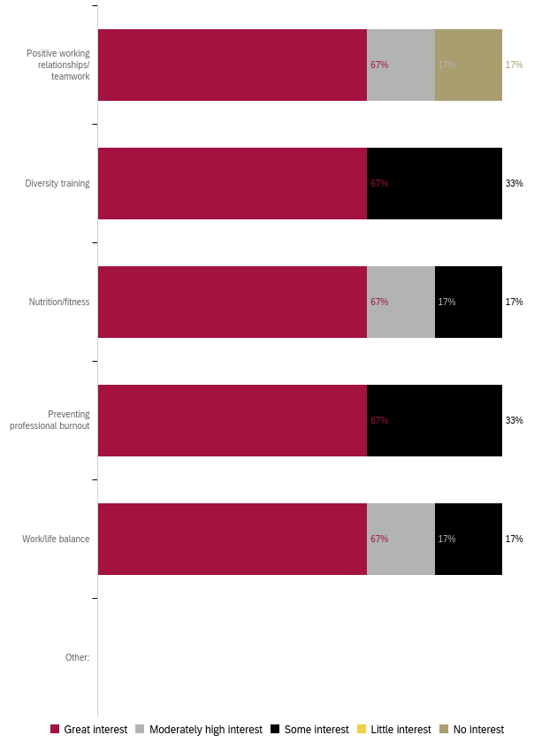
Professional Development to Enhance your Work
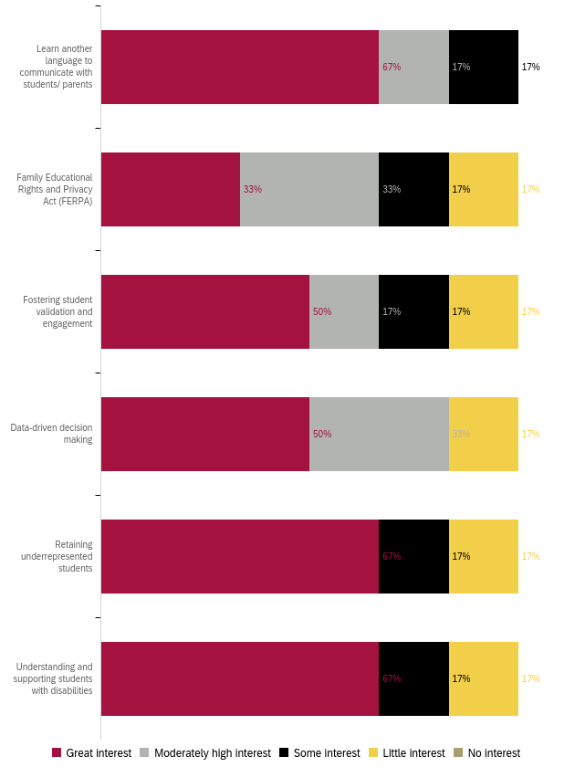

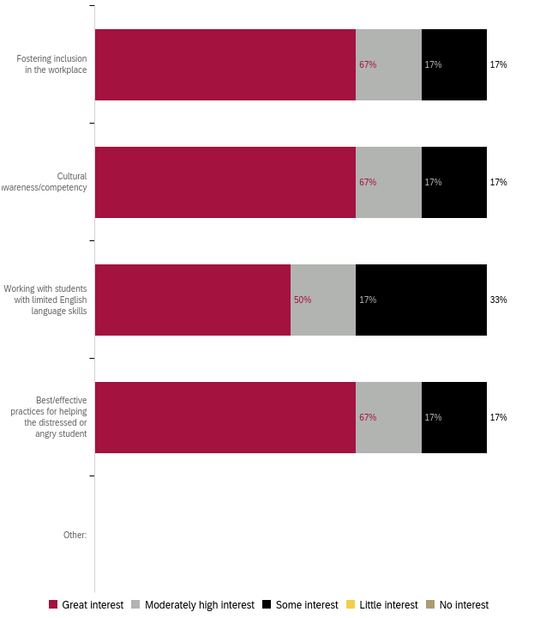

Professional Development for Leadership Skills
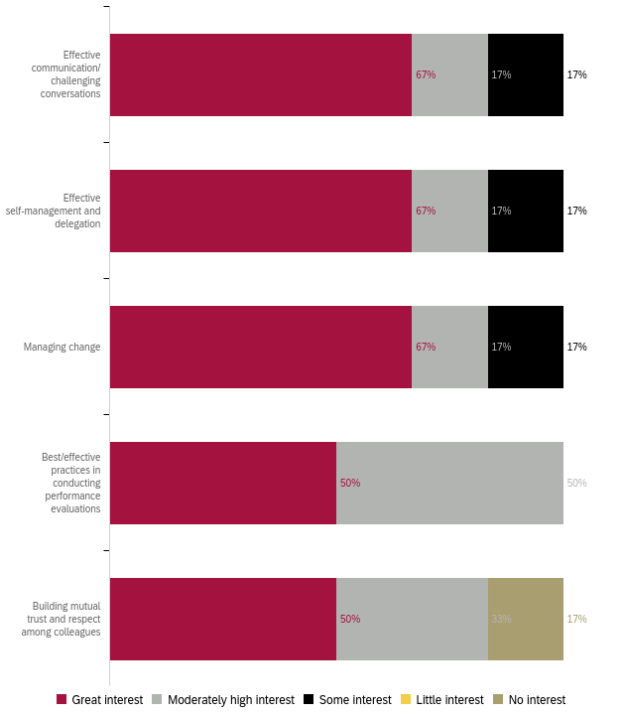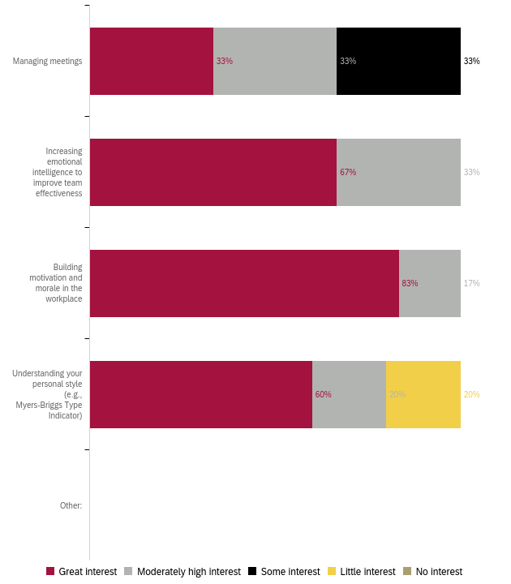

Preferred Professional Development Format 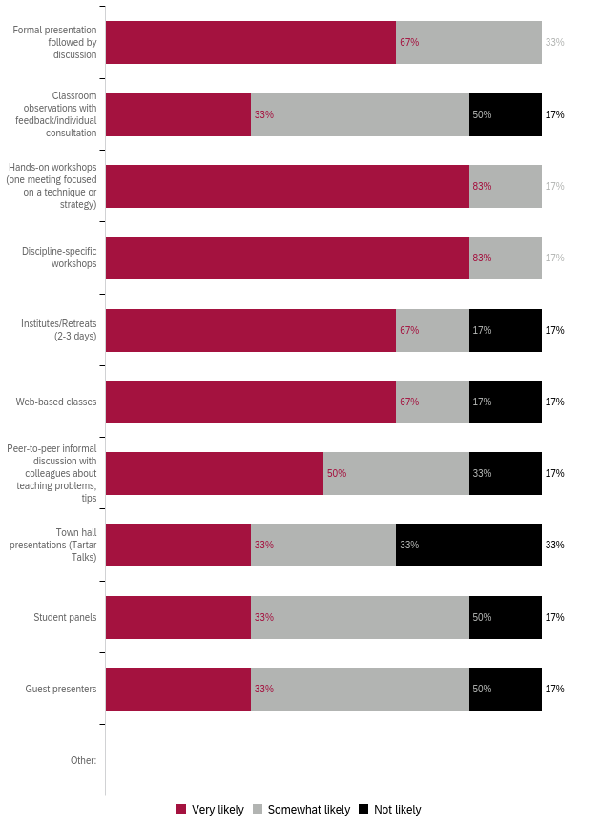

Preferred Format: Ranked 1 (first) to 5 (last)
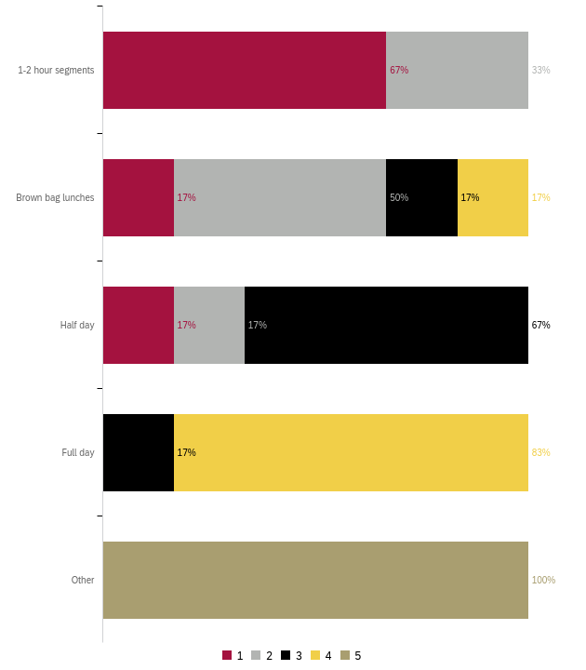
Preferred Day for Training
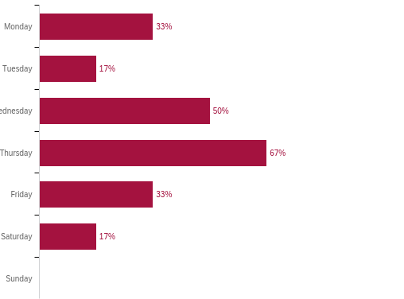

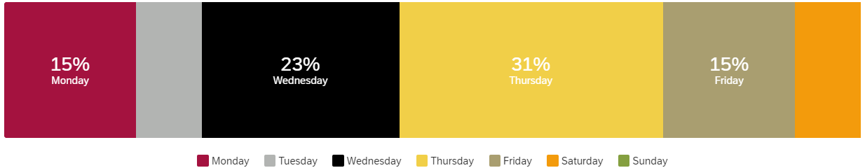

What do you need to enhance your career?
Responses:
- Nothing now (2)
- advanced critical assessment- Evidence based practice..
- Learn additional skills using technology.

What support or learning opportunity would help you do your job better?
Responses:
- More nursing focused training and teaching
- advanced critical assessment- Evidence based practice..
- na
- We have great help with Airek Matthews and Alister Caddy.

Is there anything else we should know to help build a robust, useful professional development offering?
Responses:
- Nothing now (2)
- advanced critical assessment- Evidence based practice..
- More computer apps to enhance in our teaching.

Appendix A: “Other” Responses
Non-participation “Other” responses:
- Nothing kept me from attending training (2)

PD for Technology “Specific Applications” responses:
- Use of Canva

“Other” responses listed in Appendix A
“Specific Applications” responses are listed in Appendix A

