Professional Development Needs Assessment
Spring 2023- Faculty
Social Sciences
n=13

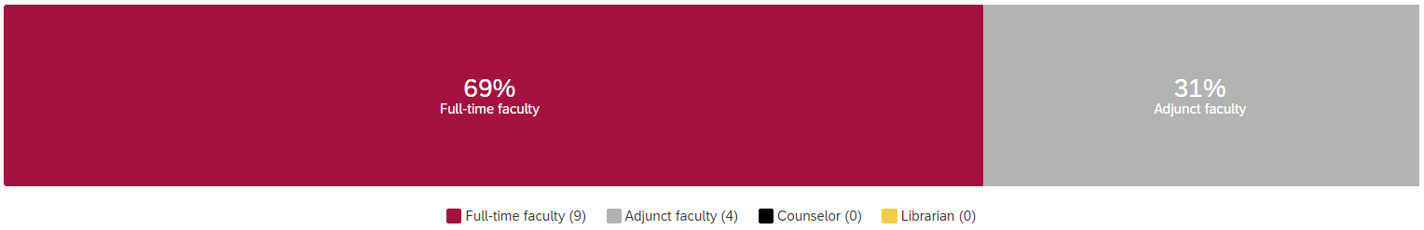

What is your ethnicity? What is your area?
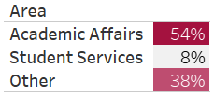
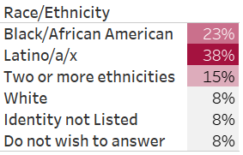

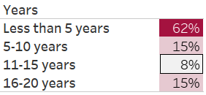
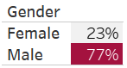
What is your gender? How long have you worked at Compton College?

What kept you from participating in professional development activities?
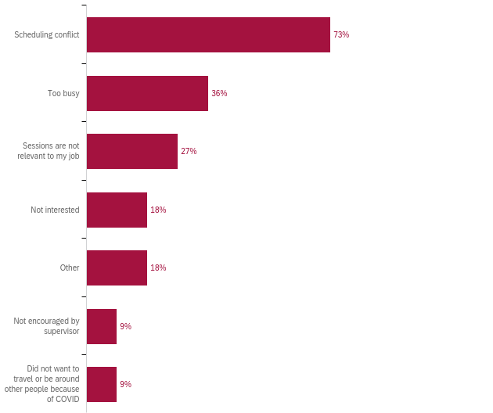

How many professional development hours did you attend in the last year?

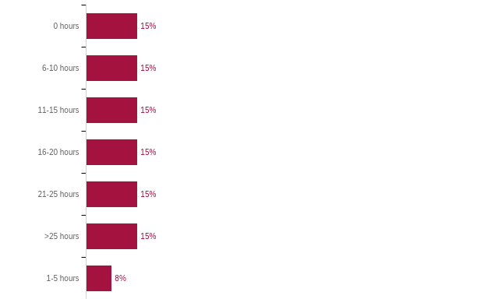

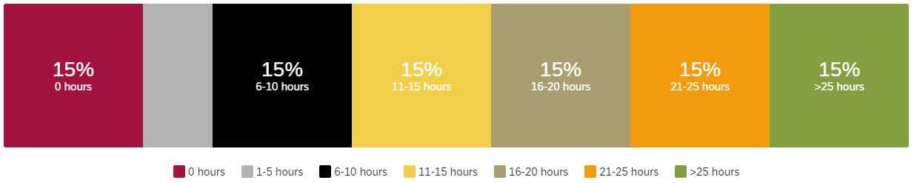

Professional Development for Guided Pathways
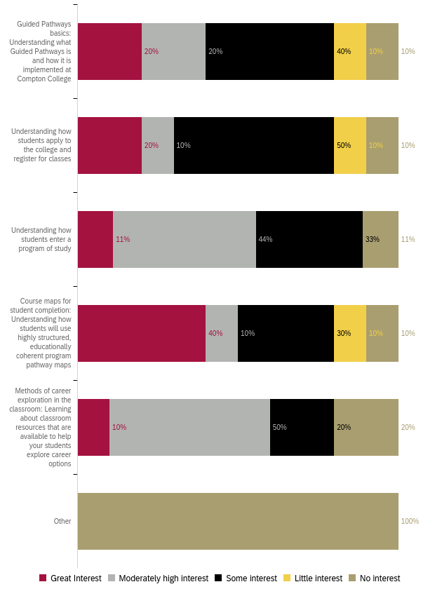
Professional Development to Enhance Teaching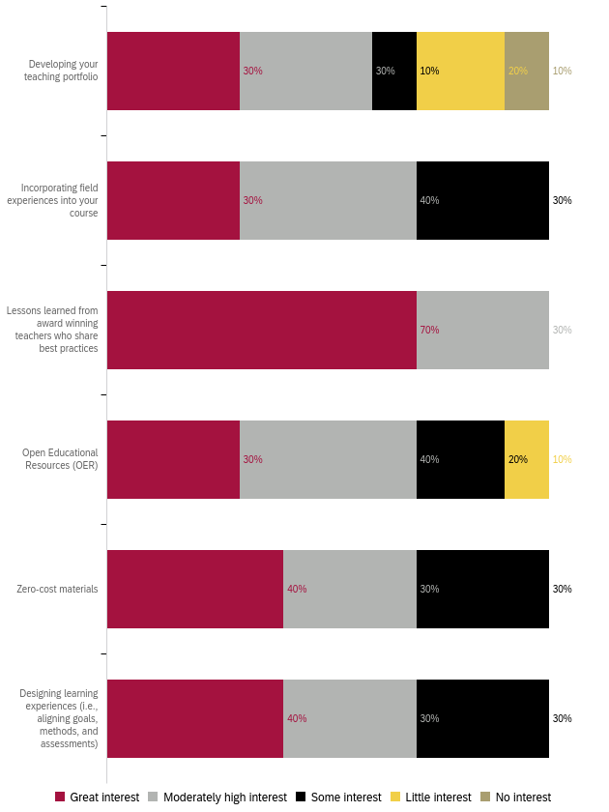
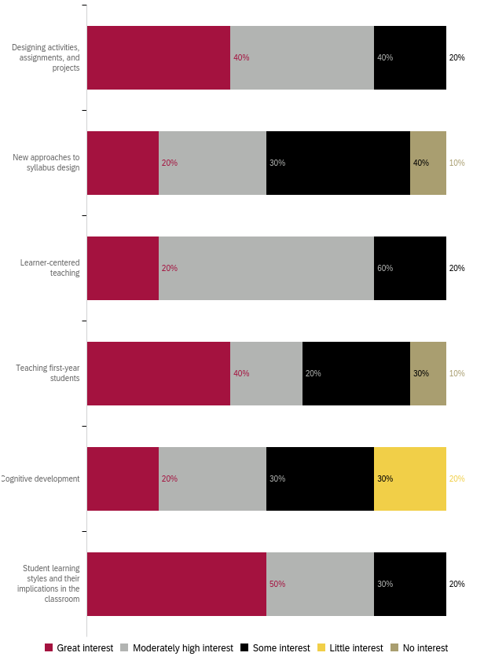
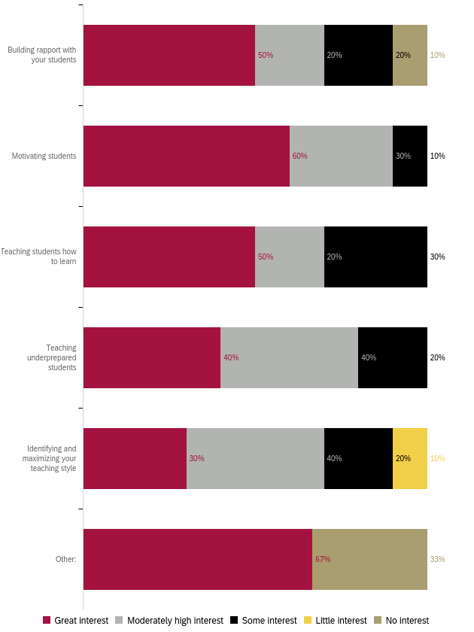
Professional Development for Curriculum Development 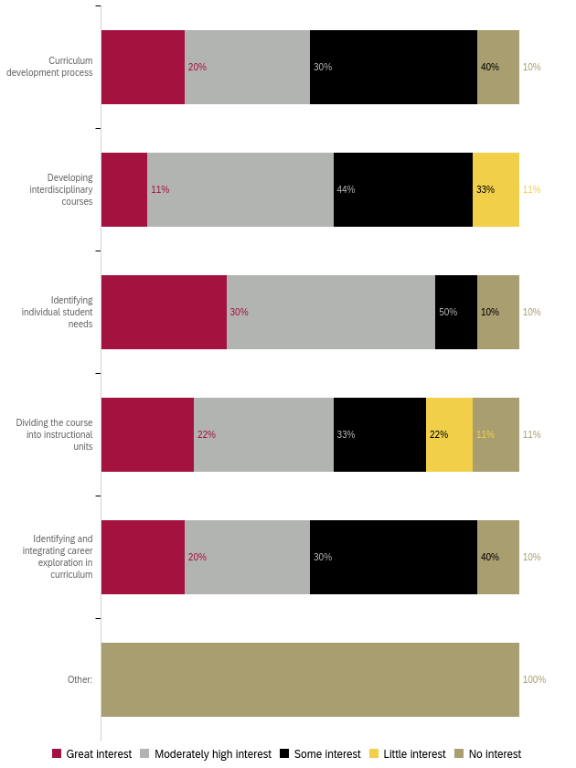
Professional Development for Diversity, Equity, and Inclusion in the Classroom
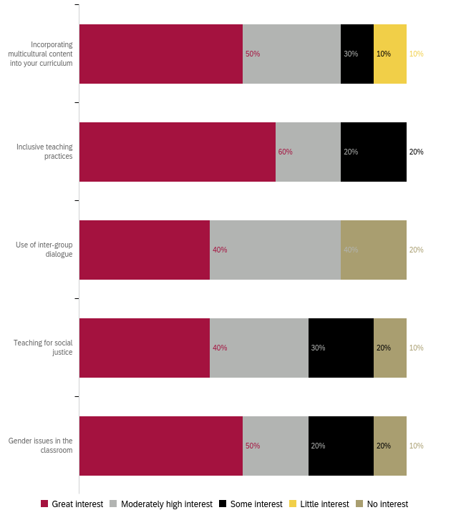

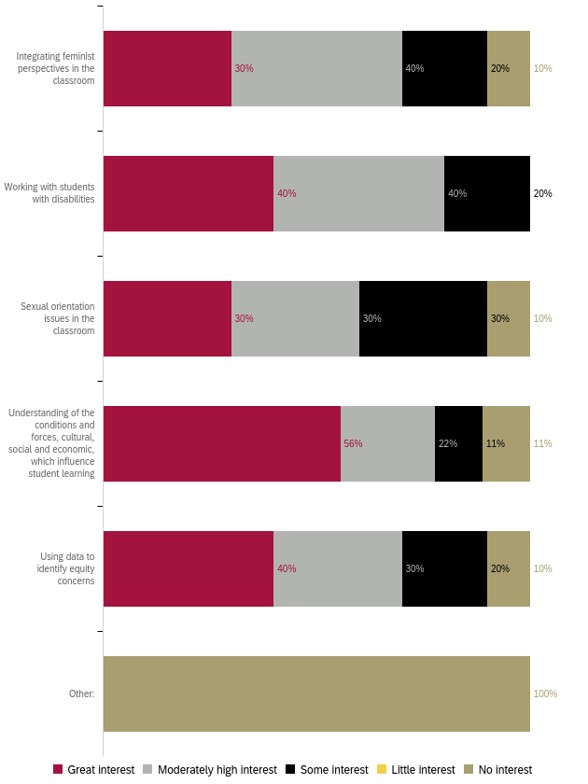

Professional Development to Improve Assessment
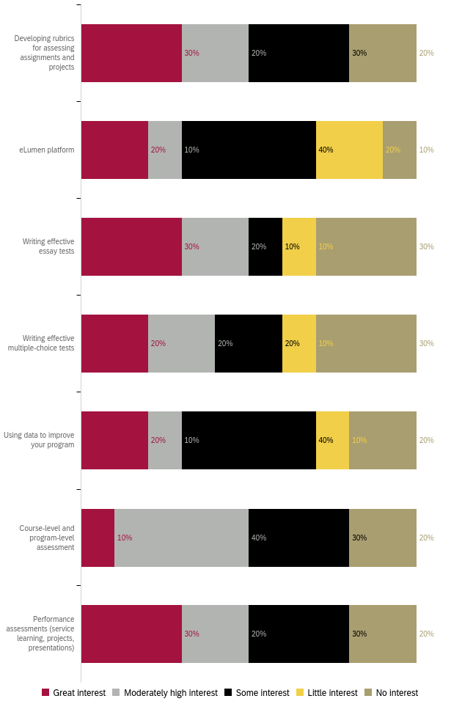

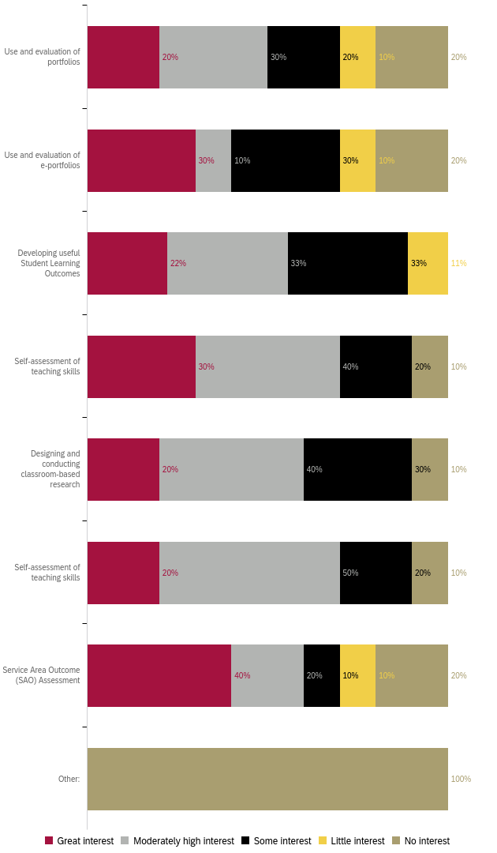

Professional Development for Use of Technology
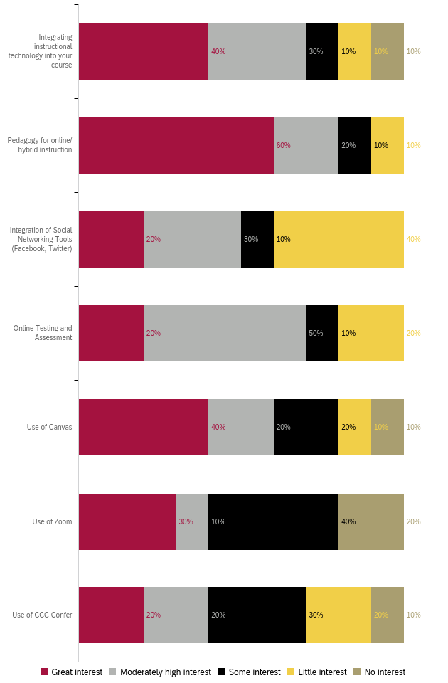
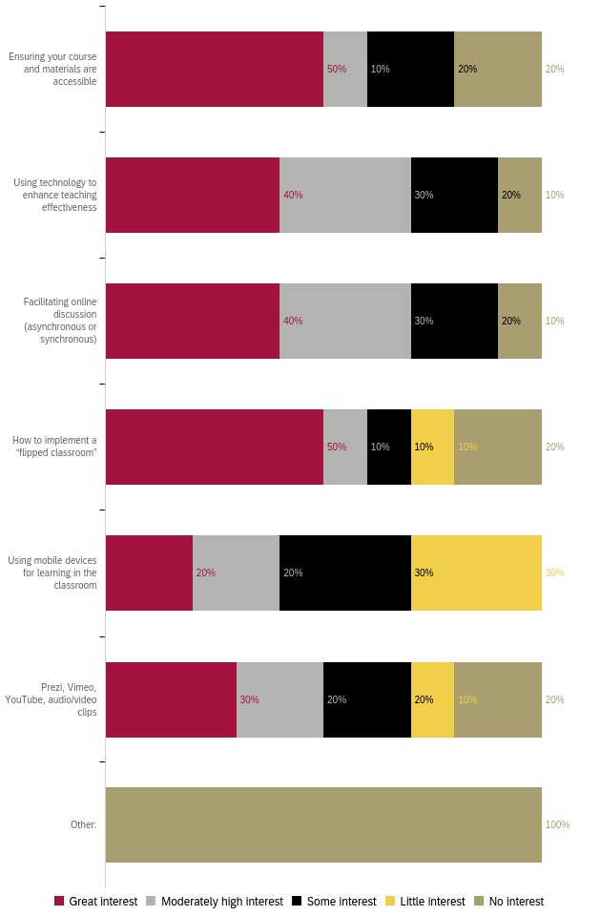
Professional Development for General Use of Technology

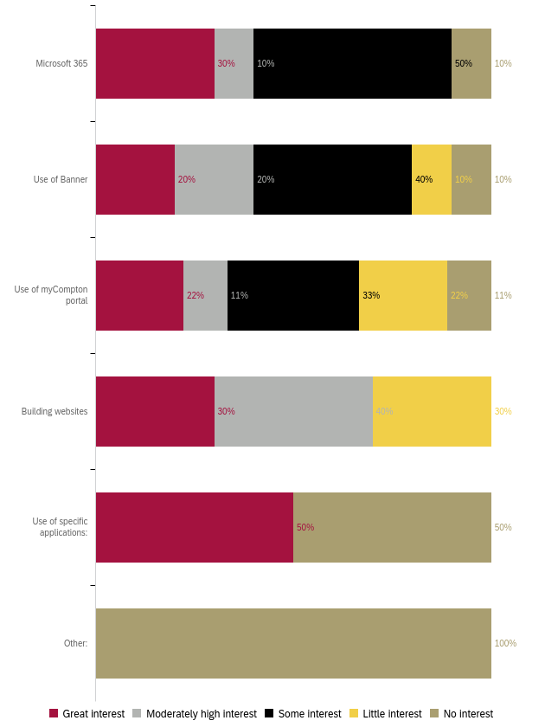

Professional Development for Classroom Management
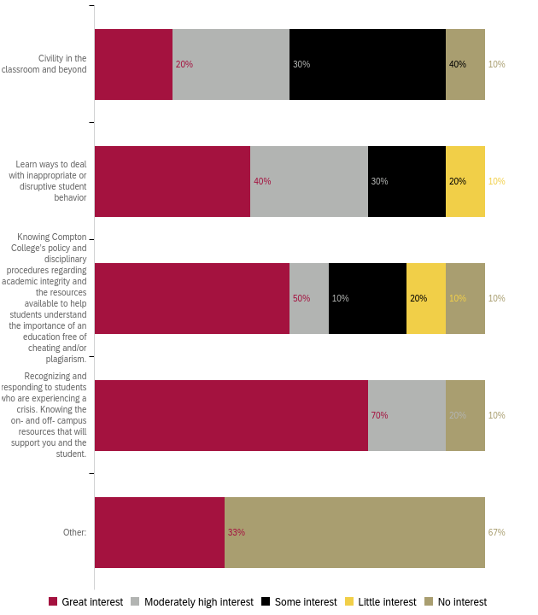

Professional Development for Compton College Policies and Procedures
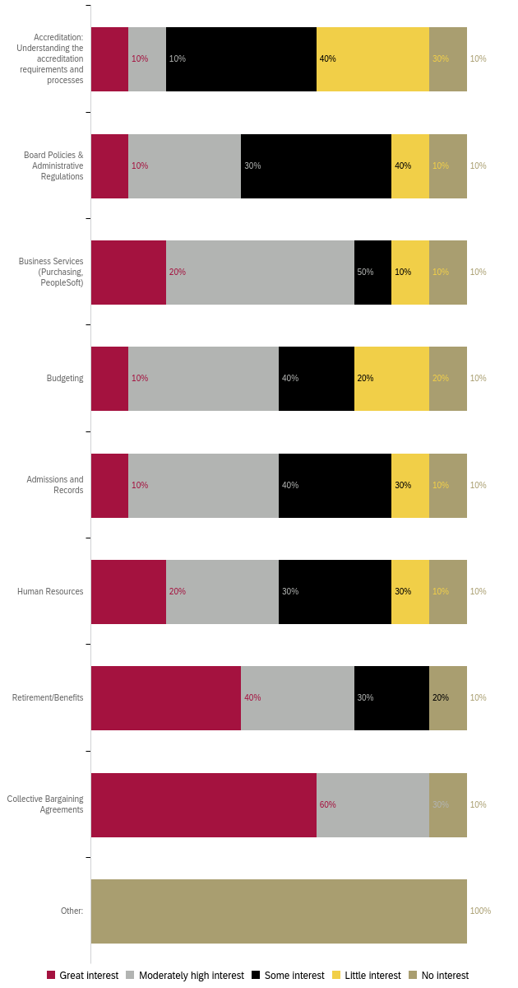
Professional Development for Health and Wellness 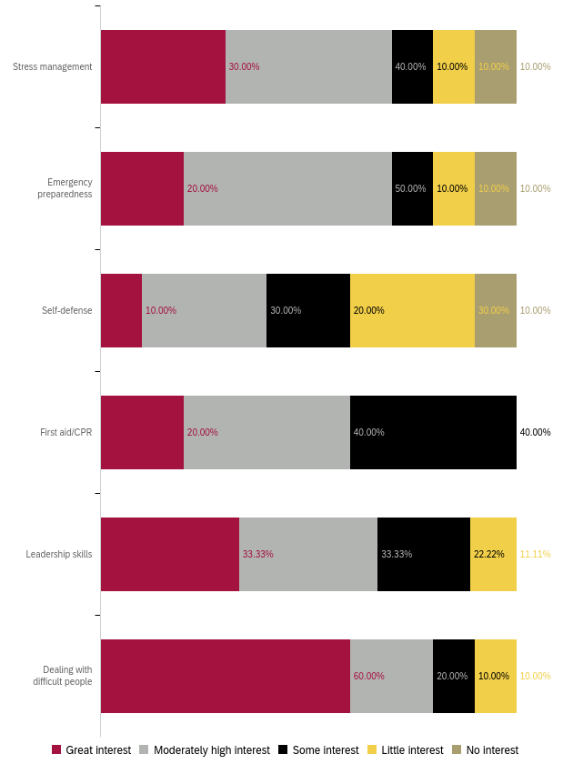

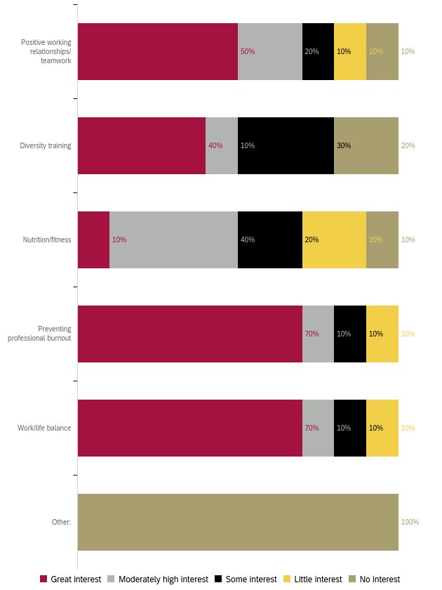

Professional Development to Enhance your Work
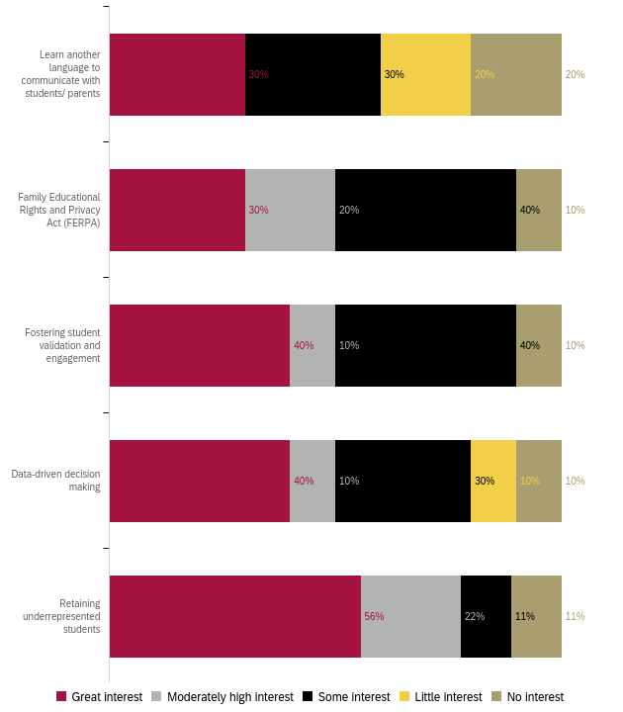

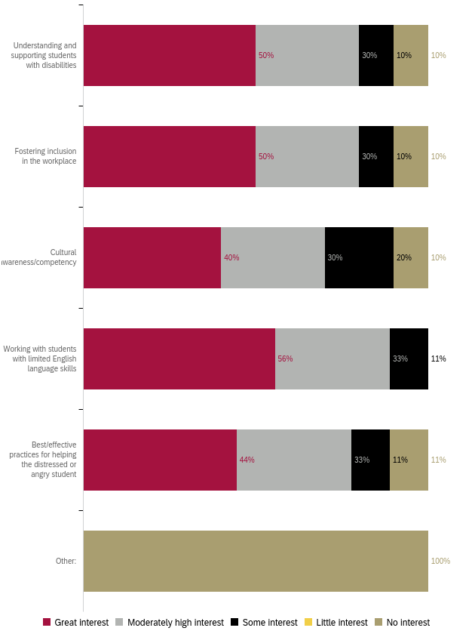
Professional Development for Leadership Skills
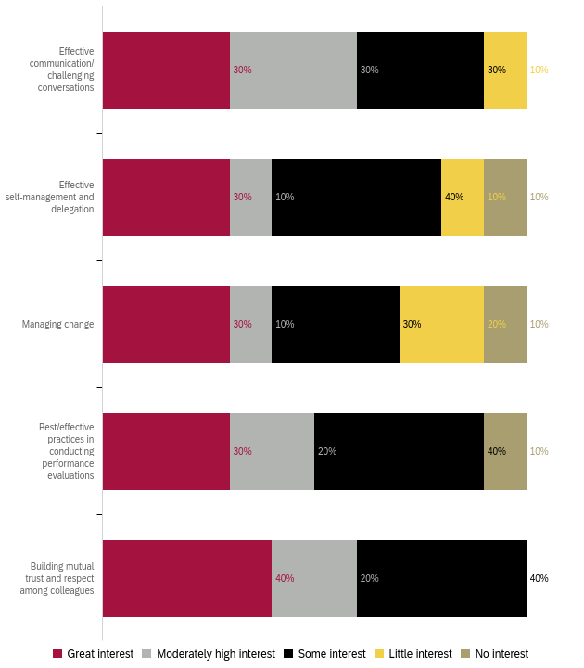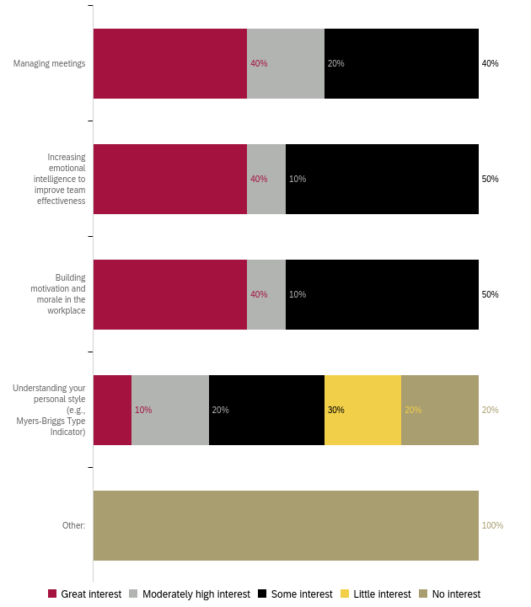

Preferred Professional Development Format 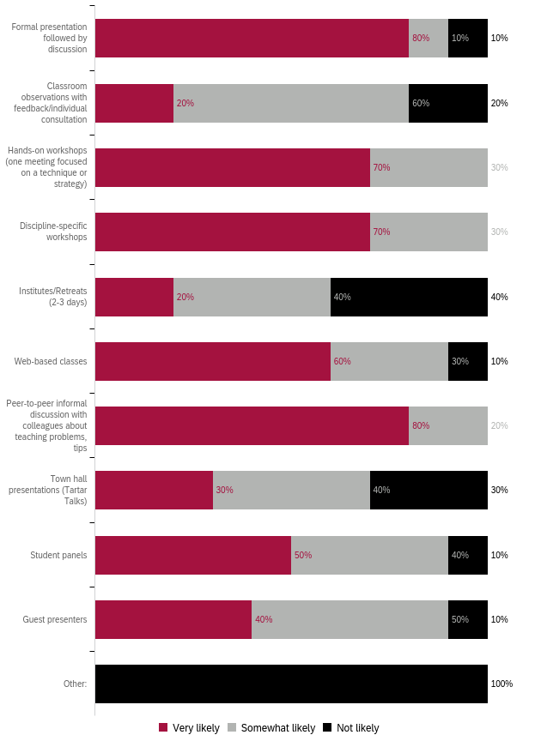
Preferred Format: Ranked 1 (first) to 5 (last)
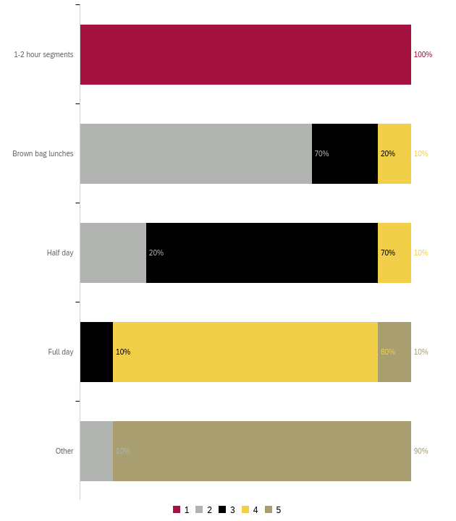
Preferred Day for Training
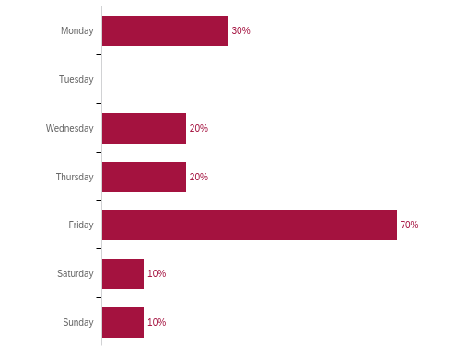

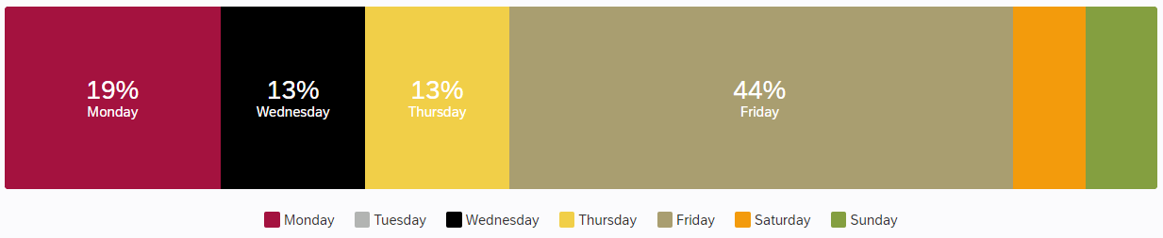

What do you need to enhance your career?
Responses:
- Better work conditions, environment, and collegiality.
- Continuous learning on best practices as a counselor at Compton College. Regular updates on information, updates on procedures, policies, and services at Compton College.
- Training on High School pedagogy and classroom management.
- More training on Dual Enrollment pedagogy and working with HS partners. Understanding Course Review, Department Review, and other profressional work on Curriqunet
- Better pay.

What support or learning opportunity would help you do your job better?
Responses:
- "Self-paced short courses in Canvas that allow to earn certificates. Please work on accessibility for faculty training. Many power points presented in trainings are not legible, are crowded, or are very hard to follow with fonts and background people choose. "
- Up to date announcements and procedures for each department and service on campus. As a newer employee to Compton College, I am becoming more familiar with all the services, how students access them and changing procedures for each department and how they provide services to students. Finding a way to keep the campus employees up to date would be great to effective serve students with out adding confusion or difficulty to the process (e.g. encouraging websites for each department are up to date and user friendly).
- PD on High School Pedagogy and Classroom Management
- More training on Dual Enrollment pedagogy and working with HS partners. Understanding Course Review, Department Review, and other profressional work on Curriqunet
- stipends to complete higher degree, MA or PhD
Is there anything else we should know to help build a robust, useful professional development offering?
Responses:
- Please include a menu of choices for professional development day. This can help to meet our needs. Having 1-2 hour segments to focus on OER workshops, SLOs, AI, developing curriculum, etc. It is frustrating to have to seat half day listening to one or two persons talk. We should have the opportunity to choose activities from variety of offerings in PD day.
- N/A (3)
- Pedagogy trainings done by other Community College faculty.

Appendix A
Barriers to Professional Development “other” responses
- Do PD outside Compton

PD to enhance teaching “other” responses
- Teaching Dual Enrollment High School Student: Prada gift and classroom management
- Dual Enrollment Teaching Methods

PD for DEI “other” responses
- Working with Formerly Incarcerated Students

PD for technology “Specific applications” responses
- CRM ADVISE

PD for classroom management “other” responses
- Classroom Manegement for Dual Enrollment

“Other” responses listed in Appendix A
“Other” responses listed in Appendix A
“Other” responses listed in Appendix A
“Specific Applications’ listed in Appendix A
“Other” responses listed in Appendix A

