Professional Development Needs Assessment
Spring 2023- Faculty
Science, Technology, Engineering, and Math
n=8

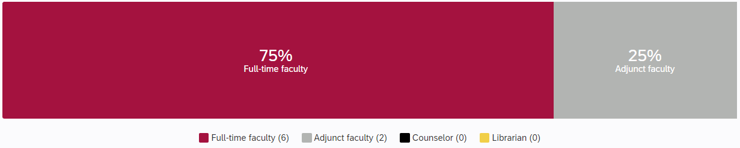

What is your ethnicity? What is your area?

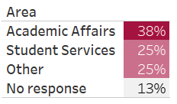
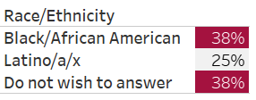

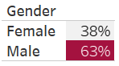
What is your gender? How long have you worked at Compton College?
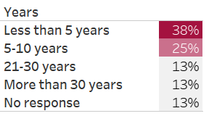

What kept you from participating in professional development activities?

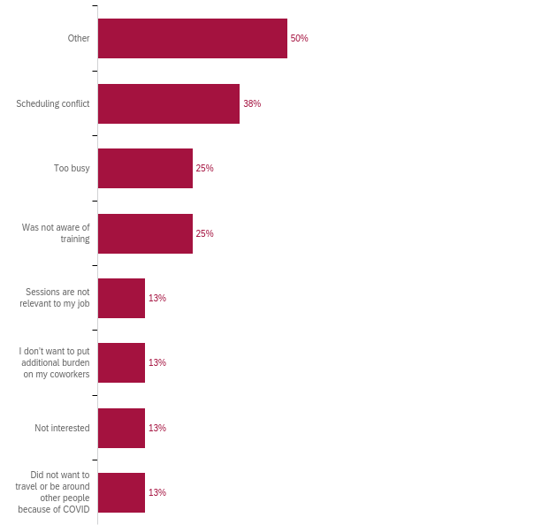

How many professional development hours did you attend in the last year?
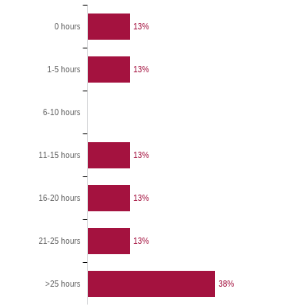

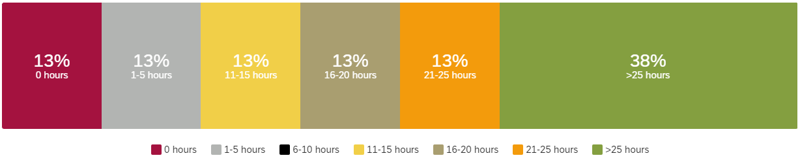

Professional Development for Guided Pathways
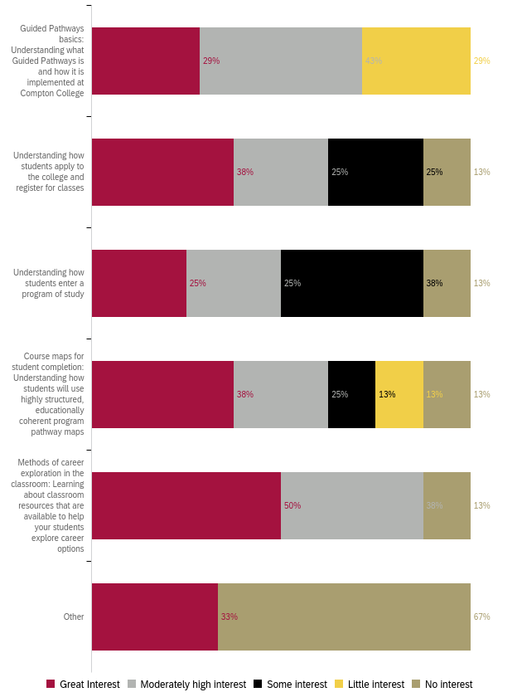
Professional Development to Enhance Teaching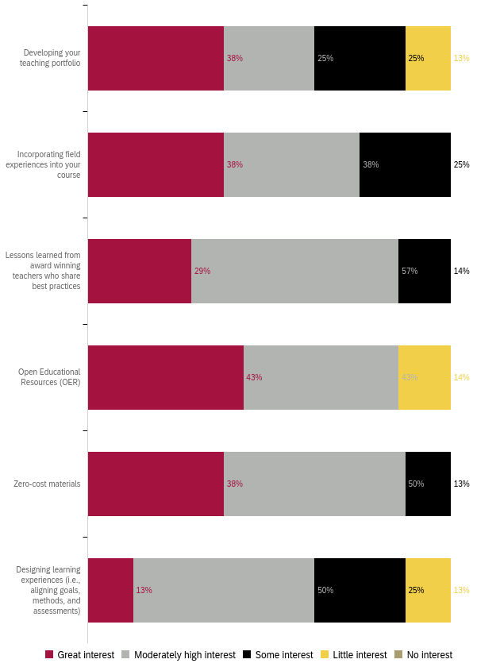
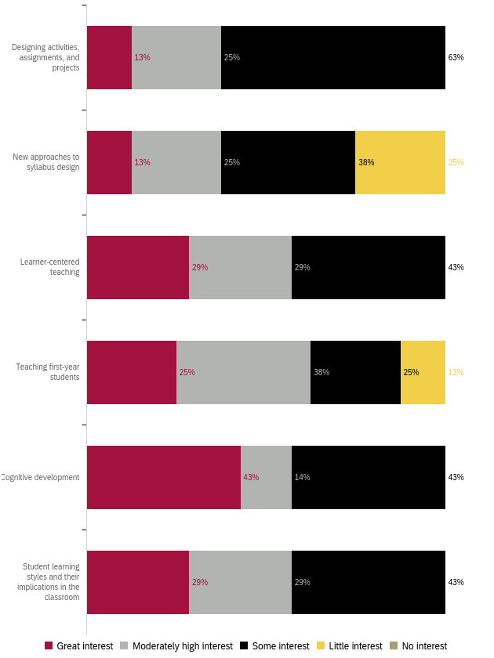
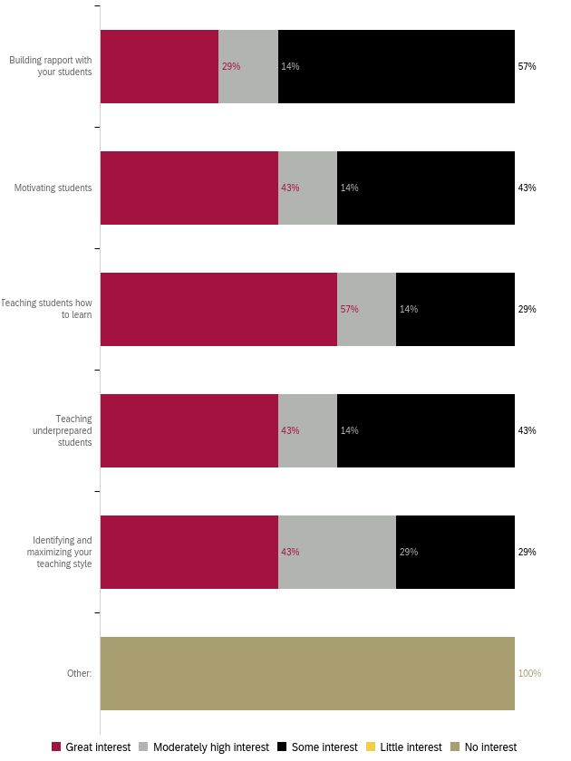
Professional Development for Curriculum Development 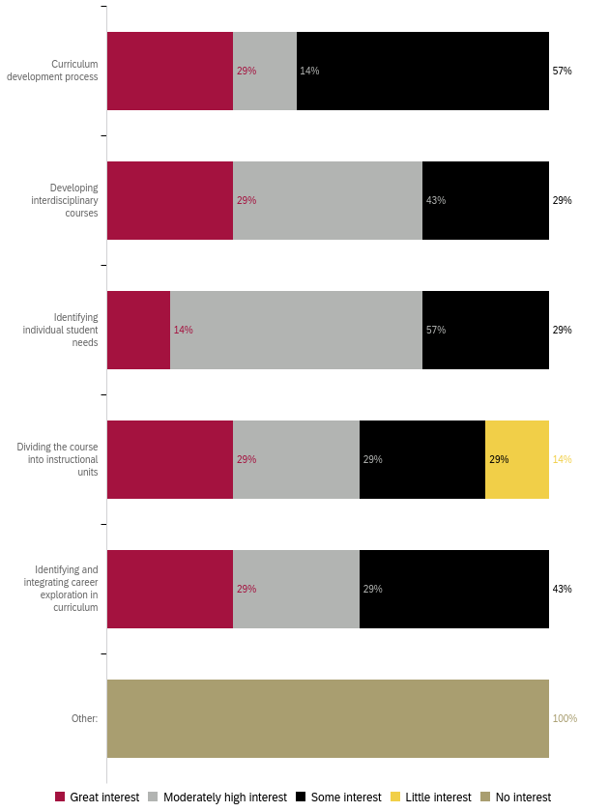
Professional Development for Diversity, Equity, and Inclusion in the Classroom
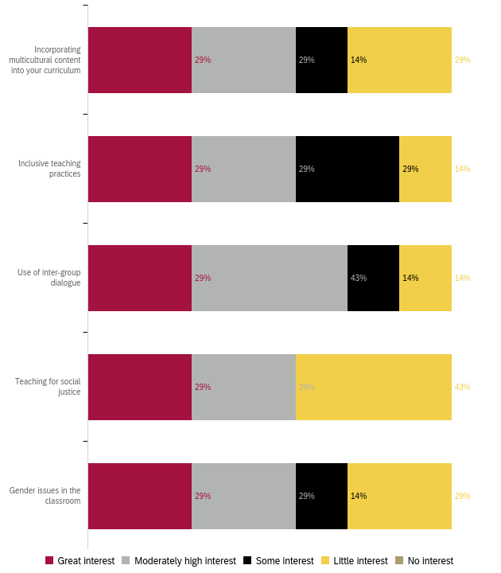

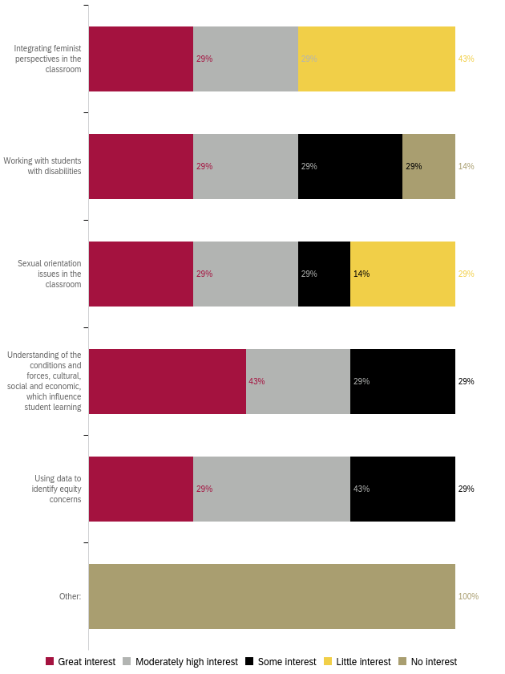
Professional Development to Improve Assessment
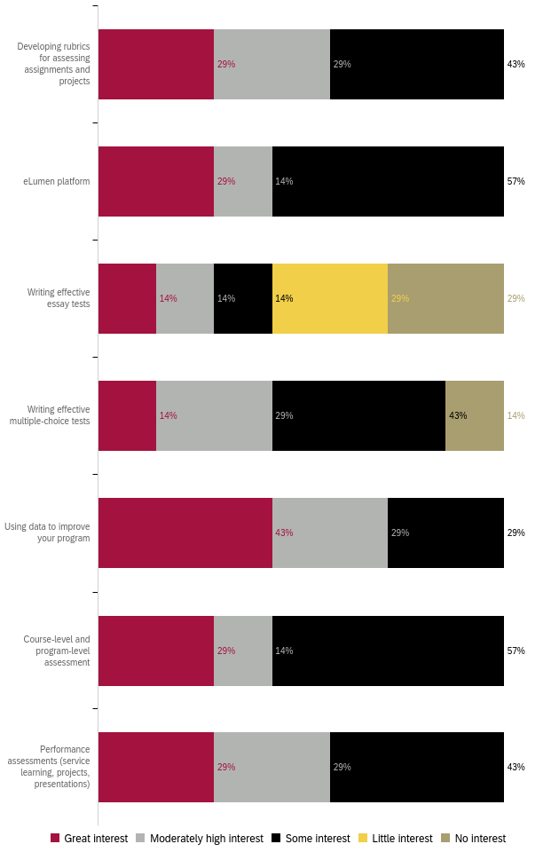

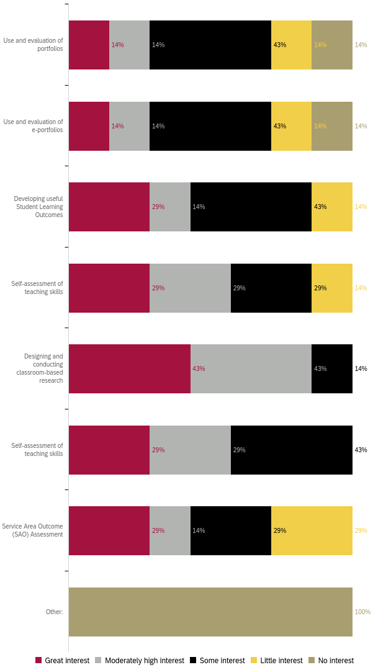

Professional Development for Use of Technology
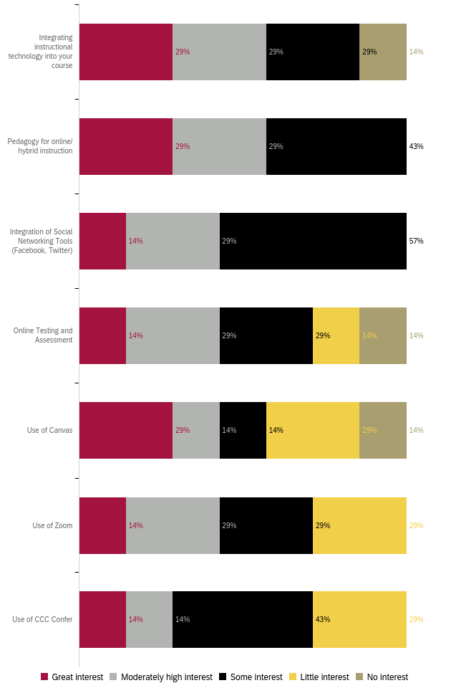
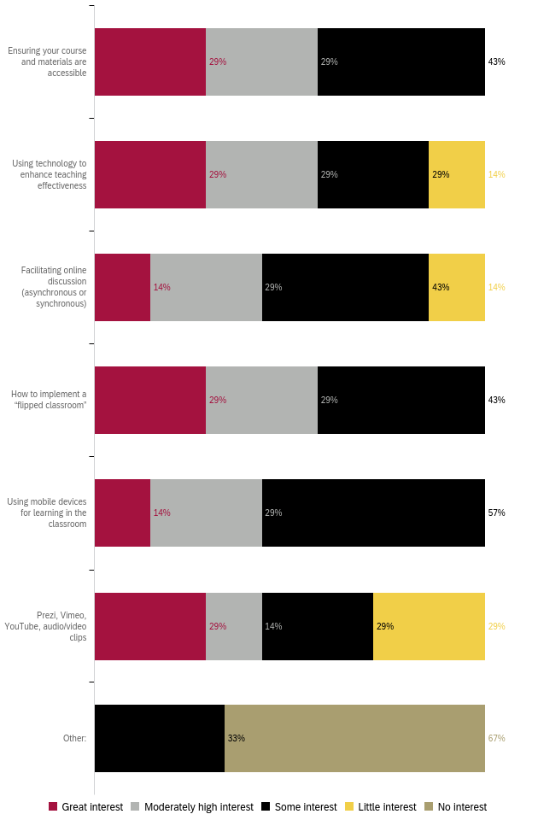
Professional Development for General Use of Technology
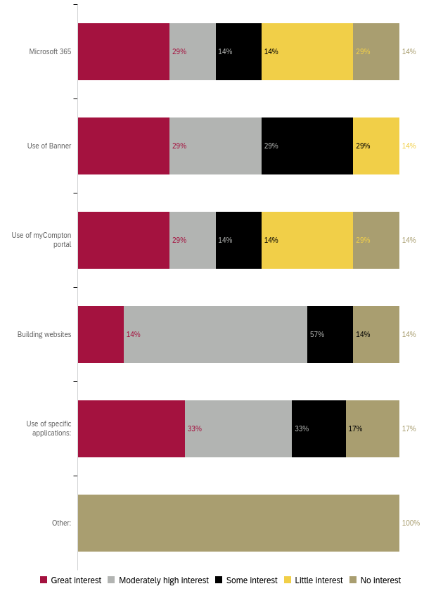

Professional Development for Classroom Management
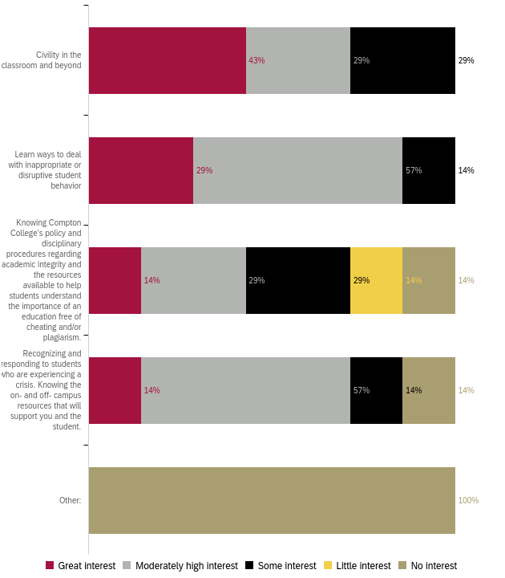

Professional Development for Compton College Policies and Procedures
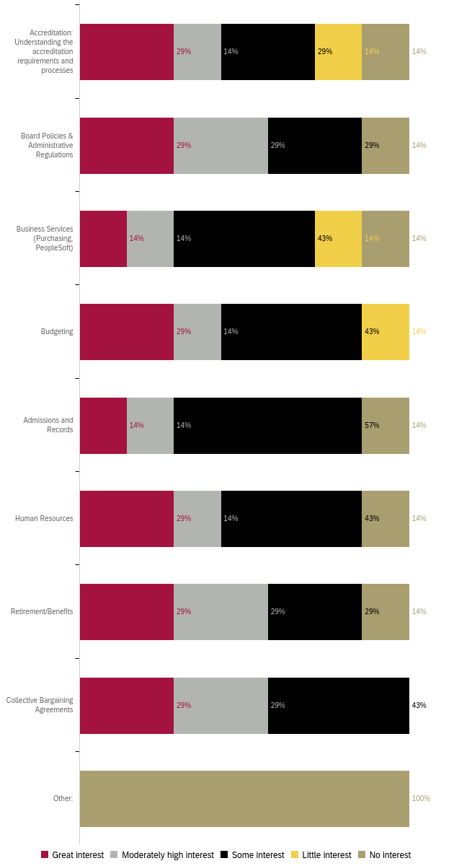
Professional Development for Health and Wellness 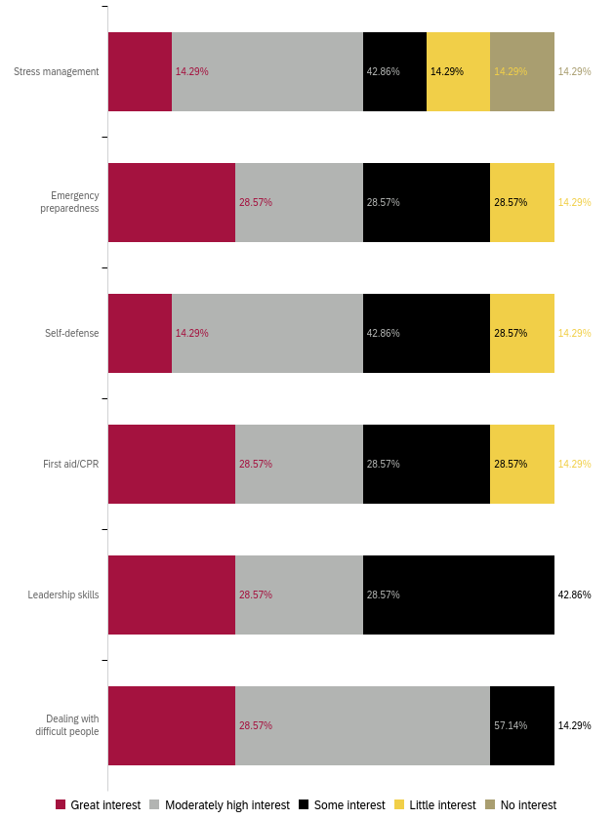

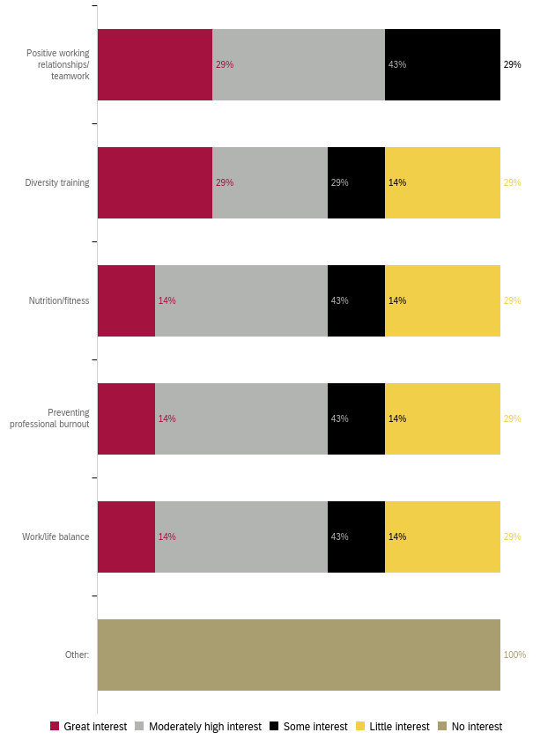
Professional Development to Enhance your Work
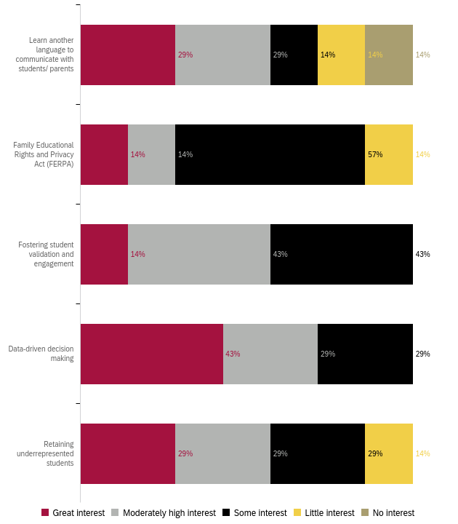

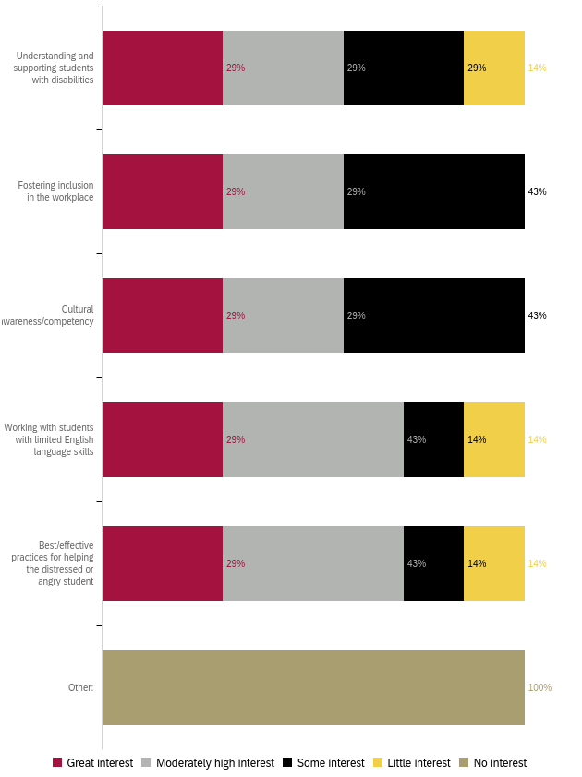
Professional Development for Leadership Skills
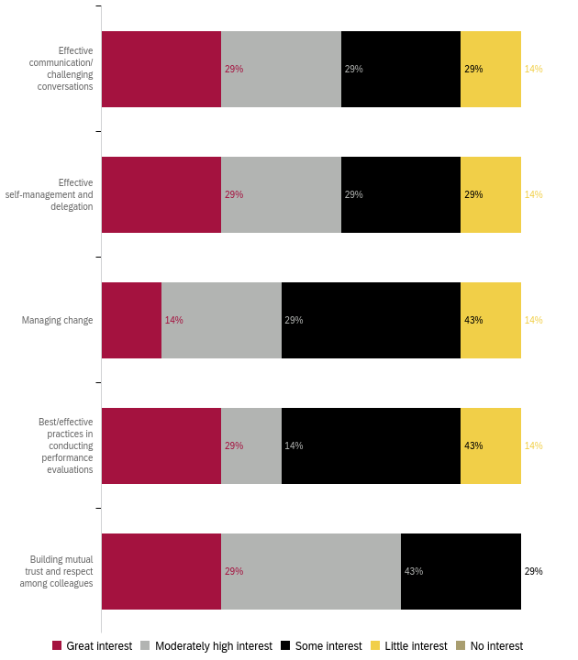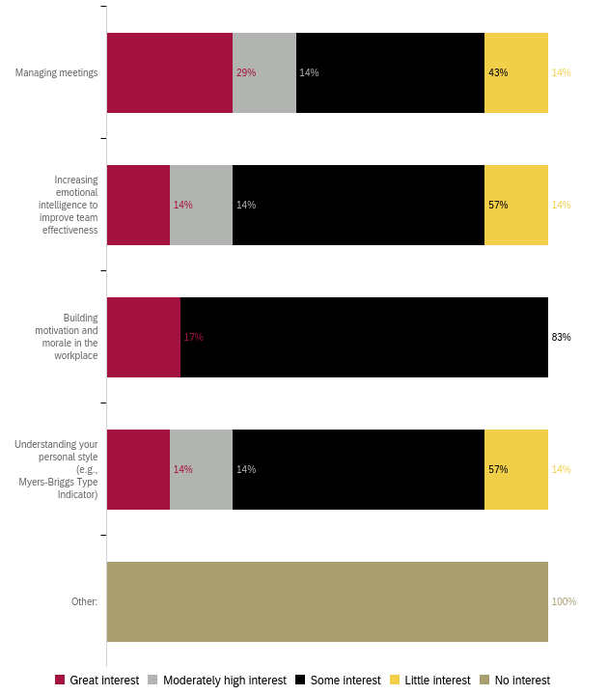

Preferred Professional Development Format 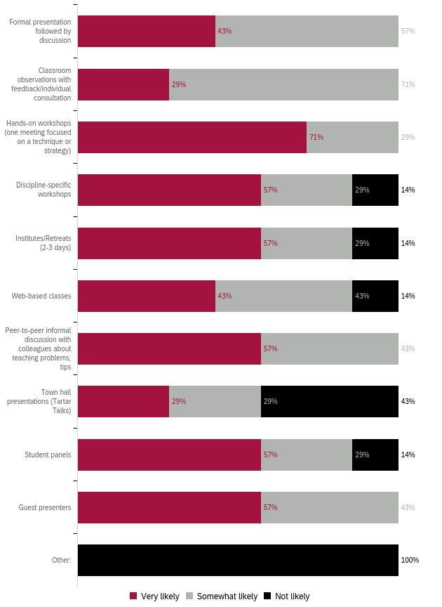

Preferred Format: Ranked 1 (first) to 5 (last)
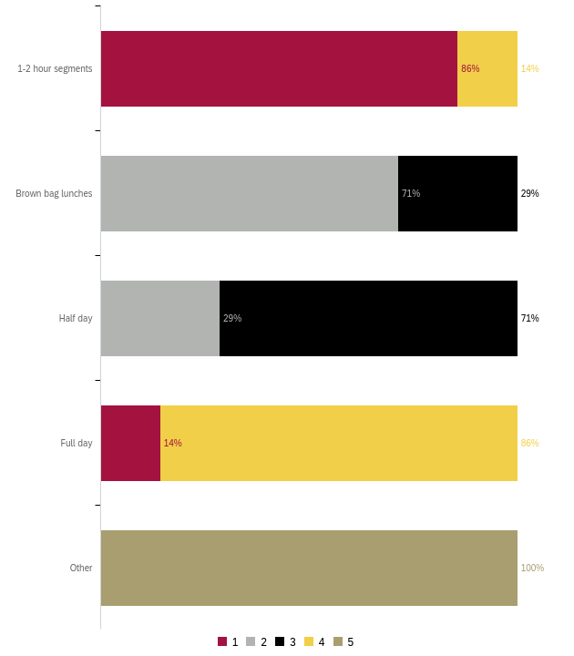
Preferred Day for Training
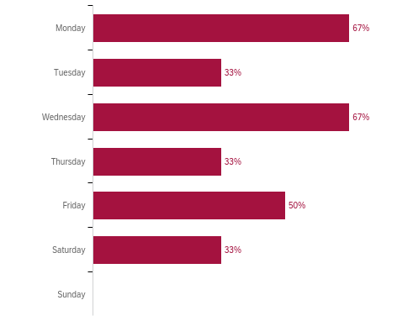

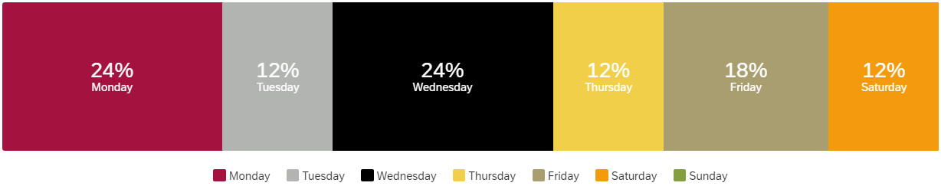

What do you need to enhance your career?
Responses:
- Salary Increase, Benefits, Tuition Reimbursement, Leadership Development, Conference Presentations
- NA
- Be able to attend convrences.
- Recognition of work ethic and my dedication to teaching.

What support or learning opportunity would help you do your job better?
Responses:
- Salary Increase, Benefits, Tuition Reimbursement, Leadership Development, Conference Presentations
- NA
- Monthly department meetings: physics and astronomy.
- I'm not sure.

Is there anything else we should know to help build a robust, useful professional development offering?
Responses:
- Nothing at this time. Thank you! (2)
Appendix A: “Other” Responses
Non-participation “Other” responses:
- I was participating in various PD activities (2)

PD for GPD “Other” responses:
- Equitable Teaching Practices
- Leading from the Middle
- Campus Collaborative PD

PD for Technology “Specific Applications” responses:
- Word
- R, RStudio, Python, Excel

“Other” responses listed in Appendix A
“Other” responses listed in Appendix A
“Specific applications” responses listed in Appendix A

